City of Sandy Springs Data Management and Artificial Intelligence Strategy

Contents
City of Sandy Springs Data Management Strategy 4
I. Goals 4
A. Data Management for the City 4
B. Governance Structure 4
II. Definitions and Conventions 5
III. Assessment and Observations 5
A. Departmental Interviews 5
B. Systems and Data 6
C. Data Maturity 7
IV. Future State 8
A. Strategic Recommendations 8
B. Data architecture re-imagined 10
V. Project Matrix 12
VI. Revision History 16

City of Sandy Springs Data Management and Artificial Intelligence Strategy

I. Goals

Data Management for the City

The goal of the City of Sandy Springs Digital Innovation Initiative (Initiative/Program) is to lay the foundation to become a more data-driven city – one that makes more informed decisions, delivers services more efficiently, and promotes transparency and accountability through the effective use of data and artificial intelligence (AI). Organizing and governing the City’s data more effectively ensures that Staff have reliable access to consistent, accurate, and trusted information. This approach supports operational improvements, strategic planning, and performance management to enable better outcomes for the City.

The Program will prioritize building the internal capacity to use data confidently and responsibly, elevating Staff skills in data literacy, analytics training, and exposure to AI. By encouraging smarter use of data and equipping staff to interpret and apply insights, the City can enhance decision-making, identify trends, and better respond to community needs. The Program can serve as a catalyst for a cultural shift; positioning data as a shared asset that drives digital innovation and public value.

To operationalize this vision, the City will align its data strategy with the nationally recognized framework established by the What Works Cities (WWC) Certification program. The WWC framework comprises eight foundational practices that help local governments manage and use data effectively. The foundational practices are listed below. Detailed definitions of the practices and supporting criteria are included in the appendix.

- Data Management
- Rigorous Evaluations
- Leadership and Capacity
- Open Data
- Performance and Analytics
- Data-Driven Budget and Finance
- Results-Driven Contracting
- Community Impact

The Program’s projects and initiatives will be linked to at least one of these areas to ensure measurable progress and focus. By using WWC as the structure for its strategic roadmap, the City can ensure that its actions are not only meaningful locally, but also in alignment with national standards for accountability, transparency, and use of data.

Governance Structure

Data Management Steering Committee and Technical Working Group

The Data Management Steering Committee (Committee) has been established to align the City’s data strategy with the practical realities of how data is received, used, stored, and secured. Additionally, the Committee will review data governance activities, prioritize initiatives, and provide guidance for the Technical Working Group (Working Group).

The Working Group has been established to focus on the execution of the data strategy. The Working Group includes key Staff who routinely work with and manage data across the organization. The Working Group will select data stewards that are responsible for data quality along with defining the subject areas for which they will are responsible. The Working Group will also report to the Committee on progress and how programs are performing through key performance indicators (KPIs).

Joint efforts of the Committee and Working Group will drive consistency in the use of data across the City, supporting best practices and successful adoption of tools, policies, and procedures.

Policies and Documentation

The City’s AI policy was written by the Information Technology Department (IT), prior to the formation of the Committee. This policy now is under the purview of the Committee and has been revised to keep pace with the rapid progression of AI development.

As the Program progresses, additional policies and documentation will be developed by the Committee and Working Group. Distribution of such will follow procedures as defined by City Management. Policies and documents will be reviewed annually for changes in technology, staffing, process, etc., as well as for accuracy and completeness.

II. Definitions and Conventions

Definitions and document conventions are listed in the corresponding section of the Appendix. Link is provided here: 2026 COSS Data Strategy - Common Appendix.docx. Further references to the Appendix in this document are to be found in the linked document.

III. Assessment and Observations

Departmental Interviews

Fifteen department level meetings were held to gather information for this assessment. Additional details about the meetings can be found in Section G of the Appendix.

In the absence of a formal data infrastructure, Staff have created their own solutions. Because of the diversity of applications, department sizes, and comfort level with data, each department has novel solutions to similar data challenges - extracting needed data from a system, transforming it to cleanse and organize, and organizing it in a way that can be presented for analysis.

Working in silos presents challenges when working with data, especially when the goal is to foster collaboration and data sharing across the City. It is noted there is a Staff desire to break down the silos and engage in best practice usage of data.

Systems and Data

Thirty-two (32) applications were identified in Staff conversations as sources of data that are currently in use, listed in Section H of the Appendix document.

System evaluations

To ensure the best practices are employed for data management, a representative from the Working Group is needed to review new software evaluations and purchasing decisions. This will ensure consideration of data movement, storage, connectivity, security, and analytics, eliminating the need for custom or improvised solutions over time.

Applications as data sources

Staff most commonly interact with data via an application’s reporting tools or by exporting data to Excel for manipulation. Although this manual data export is effective in delivering needed data, it results in inefficiency. As a comprehensive data management solution is implemented, Staff will more easily be able to find, connect, and use high-quality data for analysis – adding value to the time Staff spend working with available data.

Data Volume

Using industry standards and conservative growth rates, the City will have 50% more data than today within the next three years. Storage is inexpensive and multiple solutions exist to manage the data. This Program focuses on Staff access to the data, rather than managing volume of data. The goal is to identify a data platform that enables significant data volumes while also performing queries and analysis quickly.

Movement of data and storage

Exported files that are copied, stored on share drives, or emailed introduce security risk without proper role-based access. The Program will include Staff education to enable safe, secure data transfers, foregoing manual exports and proliferation of files for data management reduces risk and can automate data transfers more effectively.

Although data storage costs are generally low, liabilities and legal implications of long-term storage must be considered. In a centralized infrastructure, rules can be written to archive, transfer, and purge data in accordance with organizational policy.

System observations

Approximately 8-9 terabytes (TB) of data exist across City applications and SharePoint. Another 80 TB of data exists on a collection of network storage. The network storage is a combination of shared drives, OneDrive, and departmental data. As of this writing, 32 applications have been identified across departments, with limited standardization. Data used for analytics is often exported manually, cleansed and manipulated, before being shared internally or externally. A full list of applications in use is included in Appendix Section H.

An overview of the existing data architecture is illustrated in Figure III.1 below. Figure III.1 details only a sampling of the citywide data architecture.

Data Landscape

Figure III.1

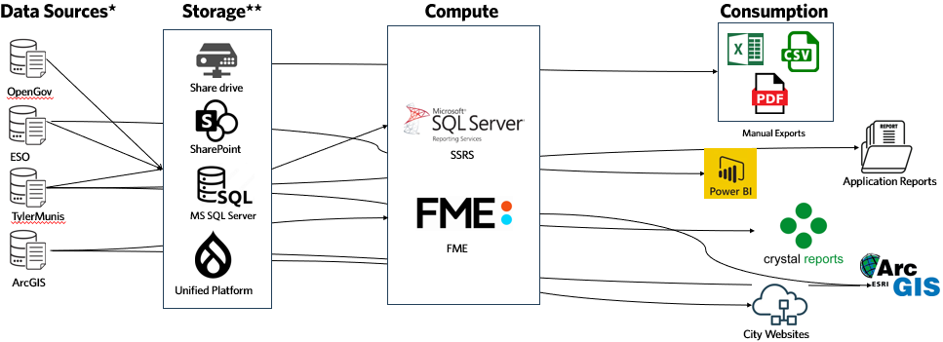

Data is stored in SharePoint, shared/network drives, SQL Server, and Unified Platform (City Websites). The data may be further processed in SQL Server Reporting Services (SSRS), FME, and consumed in a variety of channels, such as Power BI, Crystal Reports, ArcGIS, or manual exports (Excel, CSV, PDF). This landscape represents a mix of legacy systems, cloud-based platforms, and analytics tools, underscoring the complexity and importance of unifying and streamlining the City’s data environment.

Data Maturity

Figure III.2
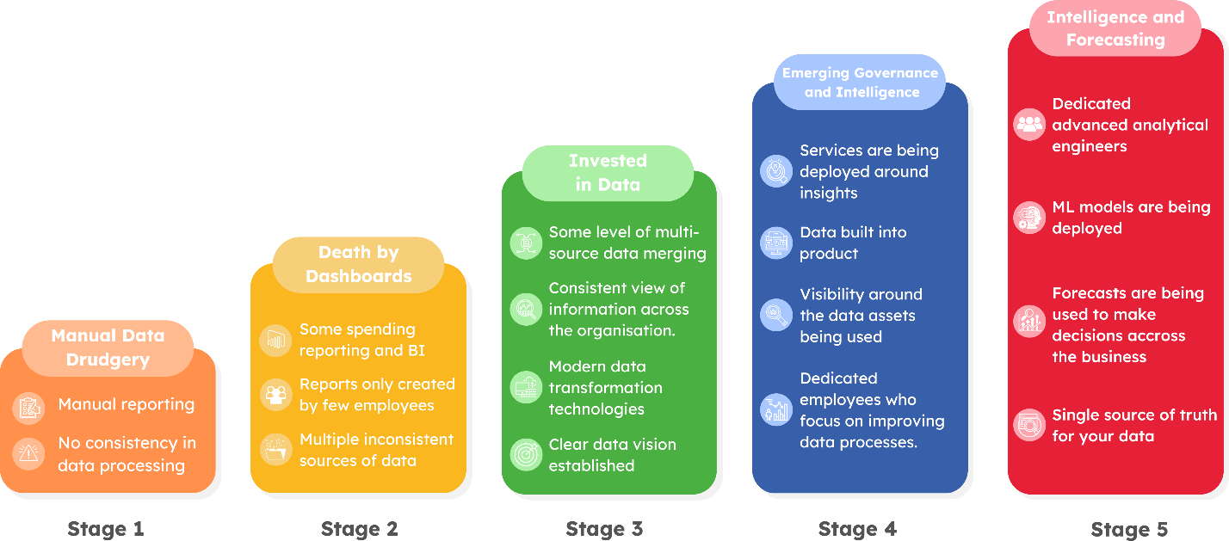

Data Maturity

In 2025, during the initial assessment, the City received a score ranging from 1.25-1.5 on the data maturity scale, represented by Stages 1 and 2 in Figure III.2. Data is often processed manually, which leads to a lack of consistency. The Fire and Police Departments are investing in Business Intelligence (BI), but reports are created by few and not utilized by all departmental staff.

The City is progressing toward components of Stages 3 and 4 in Figure III.2. A data vision has been developed. Data transformation and classification technologies are being evaluated, leading to visibility into data assets in use. These efforts will lead to more consistent views of the information across the City, along with dedicated employees focused on improving data processes.

As the City begins 2026, the revised data maturity score range is approximately 2.5.

IV. Future State

Strategic Recommendations

People

To build and sustain a data-driven culture, the City will build internal capacity through structured learning, intentional evaluation, and targeted staffing. Training on data and AI can provide Staff with additional skills to use tools more confidently. For example, orientation was provided to Staff participating in the City’s AI pilot program in Q4 2025. These efforts support the Leadership and Capacity and Stakeholder Impact domains of the WWC framework. (Additional details on projects can be found in Section V.)

During the AI pilot program, the City sent surveys at the 30-, 60-, and 90-day milestones of the program and tracked how responses change over time. This supports the WWC criteria of Rigorous Evaluations, enabling leadership to assess Staff understanding, confidence, and usage of AI and data. Insights from the comparative results will assist in prioritizing future training and any persistent barriers to adoption.

To further increase capacity, the City plans to onboard new technical and programmatic roles over time to lead data infrastructure development, project coordination, and advanced analytics delivery. Table IV.1 lists the roles, estimated costs, and WWC category associated with each recommended role.

Table IV.1
WWC Category | Role | Type | Timeline | Costs
Performance and Analytics | Data Architect/AI Architect | Consulting | Q3-Q4 2026 | 250-300 hours consulting
Data Management / Performance and Analytics | AI/Data Engineer | FTE | FY 2027 | $125,000 base salary annually
Performance and Analytics | Analyst/Developer | FTE | FY 2028 | $80,000 base salary annually
Leadership and Capacity | Project/Program Manager | FTE | FY 2028 | $100,000 base salary annually
Rigorous Evaluations | Consulting Academics | Consulting | FY 2028 | N/A

Process

To improve transparency and execution, the City has adopted Asana as the standard for work intake, project tracking, and cross-departmental collaboration for the data and AI program efforts. This has enabled better resource visibility, link tasks to strategic goals, and created audit trails essential to WWC’s Governance and Open Data standards. A dashboard connected to the Asana tasks has been created in Power BI. The dashboard has also been published to the Power BI service for easier sharing of progress.

As part of its evaluation methodology, the City will also define and publish KPIs tied to each WWC certification domain. These KPIs will be integrated into internal dashboards that track readiness progress, project milestones, and stakeholder engagement, forming a measurable feedback loop in line with Rigorous Evaluations.

Core data processes will be standardized to address how data is collected, validated, shared, and archived. These procedures will be grounded in real departmental use cases and supported by training and documentation, reinforcing operational alignment with Data Management, Budget and Finance, and Contracting goals.

Staff and stakeholder communication will be scaled using targeted outreach, executive dashboards, and recurring status updates. These efforts will help tell the story of progress – linking strategic goals with public value in support of Stakeholder Impact and Open Data practices.

Technology

The City will advance its modern, secure data architecture by investing in the latest technologies that support simplified and automated tagging and cataloging of data for inventory purposes. This technical foundation will allow staff to discover, connect, and use high-quality data at scale while ensuring integrity, traceability, and access control.

In 2026, the program is in the evaluation phase for replacing a number of back office functions tied to Lucity. Ticketing, Call Center, Customer Relationship Management (CRM), and Enterprise Asset Management (EAM) are included in the project. Benefits include core data processes that will be standardized to address how data is collected, validated, shared, and archived. Additionally, with deeper systems integration, the City will gain deeper insights into performance management through analytics and AI. Implementation of these systems and processes align with Data Management, Budget and Finance, and Performance Management WWC criteria.

A high-priority focus will be placed on data security and risk management. This includes revisiting role-based access controls, strengthening encryption protocols, and updating retention and audit policies. These improvements not only reduce organizational risk but also strengthen compliance with ethical standards for Open Data, Data Management, and Leadership and Capacity.

Data architecture re-imagined

To meet the City’s ambition of becoming more data-driven, the future data architecture must evolve from a collection of disconnected systems into a cohesive, strategic platform. This architecture will serve as the technical foundation supporting the City’s goals in transparency, accountability, service improvement, and operational efficiency.

The implementation of this data architecture supports long-term goals of centralization of data, governance, and insight. By consolidating data from numerous systems, the City can ensure data quality, improve accessibility across departments, and reduce manual reporting burdens. This unified infrastructure supports more accurate and timely analytics, fosters transparency, and creates the necessary foundation for deploying AI tools.

Figure IV.4
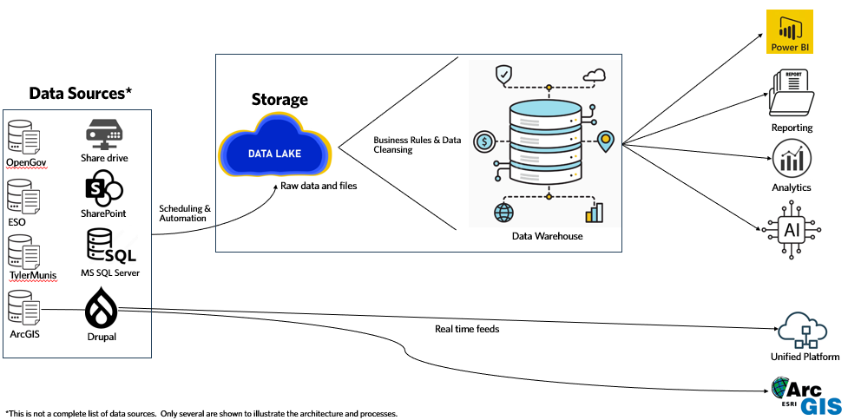

Data Sources (Input)

City data originates from over two dozen applications, including public safety systems, permitting platforms, asset management tools, CRM, financial systems, and websites. As the City modernizes these central functions, data will flow more freely to the City’s central data platform. The City has implemented a cloud-based database (Azure SQL DB) to support these new datasets.

This shift supports data accessibility and reliability, aligning with WWC criteria in Data Management and Open Data. Additionally, system-level integrations will strengthen the City’s ability to track vendor performance and procurement outcomes, contributing to more effective Results-Driven Contracting.

Data Orchestration (Scheduling and Automation)

A data orchestration platform will be implemented to automate, schedule, and secure the movement of data from source systems to the City’s central data environment. This removes the reliance on manual exports, reduces error, and supports real-time or near-real-time updates for high-priority use cases. The choice of tool is to be determined upon selection of the Digital Innovation Platform, to best align the technology with the processes and needs of the City.

Using automated orchestration, the City enhances governance, creates efficiencies, and improves service delivery responsiveness. These improvements are aligned with WWC areas of Governance, and Leadership and Capacity, providing a strong backbone for future-facing services.

Data Lake (Exploration and Storage)

The data lake will serve as the raw repository for all incoming data, regardless of its form. It allows for flexible ingestion of logs, documents, images, survey, or application data. Crucially, it enables advances analytics, testing, and AI development without impacting production systems.
A robust metadata layer will accompany each dataset, fueling a searchable data catalog accessible to Staff. Automated metadata processing tools will be evaluated as the infrastructure and implementation of the data lake takes shape.

With metadata applied across datasets and made searchable via a data catalog, the architecture will facilitate deeper insights and internal discovery. This approach directly supports Performance and Analytics, Rigorous Evaluations, and Open Data by making datasets accessible for exploration, analysis, and transparency.

Data Warehouse (Source of Truth)

The data warehouse transforms raw information into curated, quality-controlled datasets used for City analytics and AI. This is where cross-departmental KPIs, funding analysis, and trend visualizations will be maintained. Governance rules – including data validation, lineage, and quality monitoring will be embedded in this layer.

This governed analytics layer will become the cornerstone of decision-making for the City. Its alignment with WWC’s Data-Driven Budget and Finance, Performance and Analytics, and Data Management criteria ensures the City’s reporting systems are both credible and impactful.

Reporting, Analytics, and AI (Output)

Once data is curated and reliable, it can power a wide range of outputs from departmental dashboards and public portals to predictive models and AI-enabled services. This supports use cases like performance scorecards, spatial analysis, image classification, and trend forecasting. Further, these outputs will be tracked and evaluated to ensure alignment with City goals and outcomes.

The delivery of insight through dashboards and AI tools supports a culture of measurable results. This output layer exemplifies WWC principles of Stakeholder Impact, Rigorous Evaluations, and Open Data by providing residents, Staff, and leadership with clear, actionable information to drive outcomes.

V. Project Matrix

The following list of projects are examples that include a brief description of what it is, cost estimation, description of value, and duration. Some are a one-time cost while others may have ongoing costs, such as software subscriptions, or training programs.

Figures V.1 and V.2 illustrate the timeline at a high level, while Table V.1 adds cost, resource, duration, value, and priority. Not all projects are explicitly required but exist as recommendations based on the City’s current maturity level and anticipated needs. If time and resources are shifted, the list of projects can similarly be adjusted.

Figure V.1
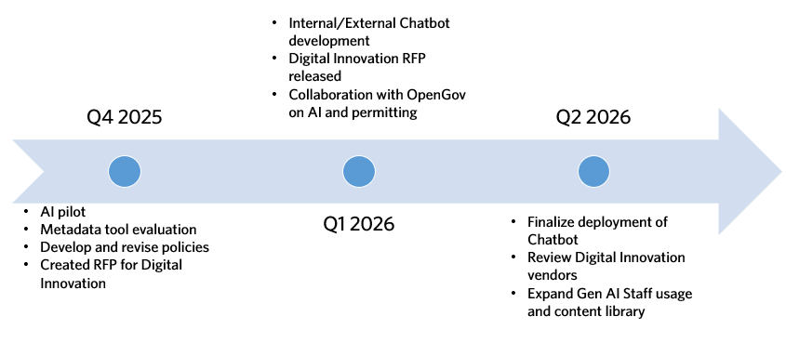
Figure V.2
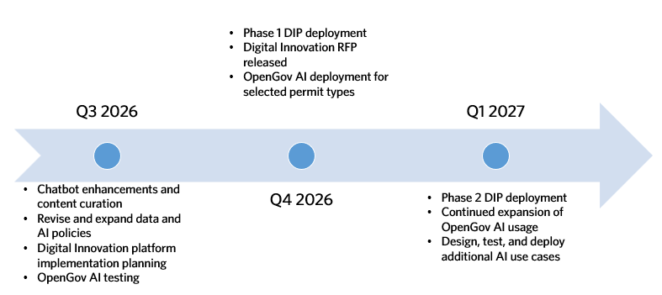

Table V.1
WWC Practice | Name | Summary | Duration | Cost | Value | Resources | Start Date | Priority
Rigorous Evaluations – EVAL2 | AI Pilot | 90-day pilot program for 20 Staff members to use Perplexity. Complete orientation for users to navigate AI benefits, uses, and risks. | 3 months | $8,000 | Insight into time savings, workflow automation, and upskilling of Staff through increased usage of AI. | Staff | Q4 2025 | Medium
Data Management – DM2 | Metadata Tool Evaluation | Evaluation of automated categorizing and search of metadata. | Ongoing/deferred 2026 | Staff Time | Staff are more easily able to find information, classification of data assets aids in optimizing storage and more effective records retention management. | Staff | Q4 2025/deferred for 2026 | Low
Leadership and Capacity – LC2, Performance Management – PA5, Community Impact – CI2, CI3 | Created Digital Innovation Platform RFP | Development of RFP to reimagine service delivery with a strong community engagement and delivery model, while improving the way Staff interact with data. | 3 months | Staff time | Improved service delivery and resident satisfaction with real-time updates to information both for residents and Staff. | Staff | Immediate | High
Data Management – DM1, DM4, DM6, DM9 | Develop and revise policies | Evolve data and AI strategy and policy documents, create risk management for AI. | Ongoing | Staff time | Provides clarity for residents and Staff on how the City uses and evaluates data and implements AI. | Staff | Ongoing | Medium
Community Impact – CI2 | Internal/External Chatbot development | Deploy internal and external chatbots to provide improved user experience on City websites | 6 months | $24,000 | Improved search capabilities and diverted calls to the call center. | Staff, vendor | Q1-Q2 2026 | High
Leadership and Capacity – LC2, Performance Management – PA5, Community Impact – CI2, CI3 | Digital Innovation RFP released | Send out for proposals Digital Innovation RFP to update ticketing, CRM, 311, EAM | 3 months to evaluate | Staff time | Improved service delivery, capacity, performance management benefits. | Staff | Q1 2026 | High
Community Impact – CI2 | Finalize Deployment of Chatbot | Deploy external facing chatbot | Q2 2026, Ongoing | $24,000 | Deploy chatbot to external website | Staff, vendor | Q2 2026 | High
Community Impact – CI2, CI1 | Collaboration with OpenGov, AI in Permitting | AI permitting reviews | 6-12 months | Staff time | Decrease average number of reviews permit application | Staff, Open Gov | Q1 2026-Q4 2026 | High
Data Management – DM6, DM9 | Expand Gen AI Staff usage and content library | Deploy GovAI for all Staff | 6 months | $39,000 | Increase innovation through the use of GovAI for all Staff. Improve governance by reducing “shadow AI”. | Staff, vendor | Q2-Q3 2026 | Medium
Community Impact – CI2 | Chatbot enhancements and content curation | Content management and auditing | Q3 2026, Ongoing | $30,000 | Decrease errors, hallucinations in chatbot through auditing and management of content | Staff, consulting | Q3 2026 | High
Leadership and Capacity – LC2, Performance Management – PA5, Community Impact – CI2, CI3 | Digital Innovation platform implementation | Begin planning of implementation | Q3 2026 | $1.5M | Develop implementation plan to deploy DIP for CRM/311/EAM | Staff, vendor, consulting | Q3 2026-Q4-2026 | High
Community Impact – CI2, CI1 | OpenGov AI testing | Phases 2 and 3 of OpenGov’s AI enhancements | Q3 2026 | Staff time | Collaboration with OpenGov for additional iterations | Staff, vendor | Q3-Q4 2026 | High
Leadership and Capacity – LC2, Performance Management – PA5, Community Impact – CI2, CI3 | Phase 1 DIP Deployment | Deploy DIP | Q4 2026 | Budget tied to above | Deploy platform and transition from Lucity | Staff, vendor, consulting | Q4 2026 – Q1 2027 | High
Leadership and Capacity – LC2, Performance Management – PA5, Community Impact – CI2, CI3 | Phas2 DIP deployment | Deploy DIP | Q1 2027 | Budget tied to above | Deploy second phase Lucity replacement | Staff, vendor, consulting | Q1 2027 | High

VI. Revision History

Version | Author | Date
1 | Keith McMellen | 3/5/2025
2 | Keith McMellen | 4/2/2025
3 | Keith McMellen | 4/14/2025
4 | Keith McMellen | 4/30/2025
5 | Keith McMellen | 6/2/2025
6 | Keith McMellen | 1/20/2026
7 | Keith McMellen | 4/10/2026

The document is to be reviewed and updated as needed by City Management or the Director of Data Strategy, Analytics, and AI Integration.

