March/
April 2017

PRESIDENT’S MESSAGE
Lynn Edwards, MBA, RHIT, CHSP, lyynnedwards@yahoo.com
President

Call for Distinguished Member Award Nominations
Do you know an OrHIMA member who you would like to nominate for the OrHIMA Distinguished Member Award? Nominees for the Distinguished Member Award must be an AHIMA/OrHIMA member in good standing and must meet at least two of the following criteria:

- Fifteen years’ service as an active HIM practitioner
- At least ten years’ service to OrHIMA and/or AHIMA, i.e., officer, director, committee
- chairman, project manager or member, delegate to the AHIMA House of Delegates;
- A contribution to the HIM profession in any of the following:
- Publication, Education, Systems Design, Public Relations, Research, Advocacy, etc.
Nominations may be submitted to me electronically and must include the reasons substantiating
why the person is being nominated. Consider fellow OrHIMA members you have worked or served with; that one person in the industry who took the time to mentor you and encourage your professional development; that educator who assisted you and fostered your desire for lifetime learning; that one person who was instrumental in assisting you in landing that first HIM position. Think of these people and send your nomination in to me at lyynnedwards@aol.com.

Past Distinguished Member Award Recipients
Year Distinguished Member
2016 Leann Stahn, MBI, RHIA
2015 Bonnie Altus, MS, RHIA, CHPS
2014 Dana Brown, RHIA, CHC
2009 Esther Wyatt, RHIA
2008 Pam Yokubaitis, MPH, RHIA, FAHIMA
2006 Beverlee Jackson, RHIT
2005 Kathy Phillips, RHIA
2003 Emily Wieczorek, MEd, RHIA
2001 Gloria Ahern, RHIA
2000 Diane Davis, RHIA
1999 Cheri Adams, RHIA
1998 Nona DeDual, RHIT
1997 Linda Duke, RHIA
1996 Yvonne Gergen, RHIA
1995 Piper Hooper, RHIT
1994 Patrice Spath, RHIT

Professional’s Perspective –
“Masking” Health Information Up North

By Julia Huddlestion, CIPP/US, CIPM
We have just finished a project for a customer up north, in the province of Alberta, Canada. Canadian law views the protection of privacy as a fundamental human right. The country’s general approach is to enact comprehensive information protection laws, and not allow any collection or use of personal data, including what we Americans call protected health information, unless it’s permitted under law.
Health care in Canada is delivered through a publicly funded health care system, which is mostly free at the point of use and has most services provided by private entities. It is guided by the provisions of the Canada Health Act of 1984. Several provinces have passed provincial law that’s more stringent than the Canadian federal law, and takes precedence over federal law. Alberta is one.
Alberta has a publicly administered and funded health system that guarantees universal access to hospital and medical services for Albertans. Alberta also provides many health services in addition to those required by the national Canada Health Act. Alberta Health is the provincial government department responsible for ensuring that health services in the province are properly conducted in the public interest. Alberta Netcare is the name for all the projects related to the provincial Electronic Health Record (EHR) — a secure and confidential electronic system of Alberta patients' health information.
Albertans have the option of requesting that their health information in Alberta Netcare be "masked." This means that information about an individual will not be automatically visible when a record is accessed, except for first and last name, date of birth, gender and personal health number. Masking is a way for Albertans to express their wish to limit access to their health information through Alberta Netcare.
Masks can only be requested after patient consultation with a health service provider who is participating in Alberta Netcare. The health service provider discusses the consequences of a mask with the patient, and submits the application on the patient’s behalf. In certain circumstances a health service provider is legally unable to authorize the mask, for example, if masking that information could pose a threat to public health and safety.
When a mask has been applied, the health information contained in the Alberta Netcare electronic health record will not automatically be displayed. Authorized health service providers may unmask a record in limited circumstances, such as with the patient's consent or if clinically necessary. All unmasking activity is flagged, electronically logged and may be audited. Patients have the right to request a copy of the audit logs.
The patient can request that the mask be removed at any time. A request to remove a mask may also be initiated by a health service provider if he or she becomes aware of changing circumstances that affect patient eligibility for masking.
I’m not a clinician, so I have no idea what challenges patient initiated masking poses to care delivery. What I find remarkable, as a U.S. based privacy professional with a HIPAA Privacy Rule practice, is the presumption that the patient knows best in the Albertan law, as opposed to the health care provider knows best presumption that forms the basis of our law.
About Julia Huddleston –
Julia Huddleston, CIPP/US, CIPM, is the Chief Financial and Operating Officer at Apgar and Associates, LLC. Julia works with clients throughout the United States to implement and manage robust privacy and security programs to safeguard valuable patient and customer information.
Both the Certified Information Privacy Professional (CIPP) and the Certified Information Privacy Manager (CIPM) certifications are awarded by the International Association of Privacy Professionals. Privacy professionals are the arbiters of trust in today’s data-driven global economy. They help organizations manage rapidly evolving privacy threats and mitigate the potential loss and misuse of information assets. Julia also serves as the 2016-2017 IAPP KnowledgeNet Co-Chair of the Portland, OR region.

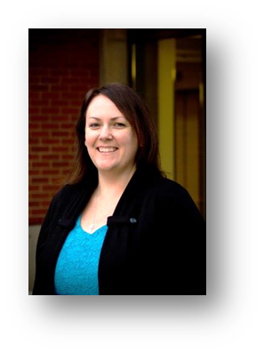
Welcome to Spring – It’s Election Time!

Aurae Beidler, MHA, RHIA, CHC, CHPS aurae.beidler@gmail.com
President-Elect

Mark your calendars! The 2017 OrHIMA Board of Directors election is upon us. Voting opens March 13th and your vote counts! KnowledgeConnex will help by sending notices out on a regular basis to our membership to encourage participation in the voting. If you have any questions, please contact:

Aurae Beidler, MHA, RHIA, CHC, CHPS
OrHIMA President-Elect
Aurae.beidler@gmail.com, 541-768-6057

The Latest Career Resources – Straight From AHIMA
Career Reading List  The Most Predictive Factors of Post-Graduate Wages - The Atlantic  The Perfect Responses to These 8 Common Interview Questions - Glassdoor.com  The 3 Most Important Things Your First Job Will Teach You - Motto  6 ways to show your interviewer that you really want the job - LinkedIn | Current Job Opportunities  Clinical Documentation Improvement Specialist, McHenry, IL  Remote Medical Inpatient (IP) Coders - Certification required, Work from Home  AR Specialist, Alpharetta, GA  Regional HIM Sales Directors // 50-60 Percent Travel, Your Home Office  Client Application Engineer, Alpharetta, GA  View more available positions.
AHIMA Data Analytics Workshop
Chris Apgar, CISSP, capgar@apgarandassoc.com
Director of Communications

LINK: http://www.ahima.org/events/2017mar-dataanalytics-workshop-chicago

AHIMA’s Data Analytics Workshop is taking place on March 29 in Chicago, IL. You will learn how your work contributes to data analytics, informatics, and industry expectations and you’ll receive recommendations on how to become the “go to” person for accurate and dependable healthcare information in your organization. Register now for the Data Analytics Workshop at http://www.ahima.org/events/2017mar-dataanalytics-workshop-chicago.
- Find out how your work contributes to data analytics, informatics, and industry expectations at the Data Analytics Workshop. http://www.ahima.org/events/2017mar-dataanalytics-workshop-chicago
- Become a "go to" person for accurate and dependable healthcare info. Learn to analyze, interpret, and manage data. http://www.ahima.org/events/2017mar-dataanalytics-workshop-chicago

I’m excited to let you know about AHIMA’s Data Analytics Workshop. The workshop is taking place on March 29 in Chicago, IL.
I would like you to take a minute and answer these questions:
- Do you work with healthcare data, but need more in-depth knowledge and the ability to transform that data into meaningful information?
- Do you have the skills to move into the future?
- Do you need to understand how the work you do contributes to data analytics, informatics, and higher expectations?
If you answered YES to any of these questions, you'll want to attend the Data Analytics Workshop.
At this one-day, hands-on workshop, participants will learn the processes essential for examining data to uncover hidden patterns, correlations, and other useful information for making better decisions. Many HIM and healthcare professionals, by the nature of their jobs, work with healthcare data every day. By knowing and understanding how to analyze, interpret, and manage that data, those individuals are seen as the “go to” people for accurate and dependable healthcare information. View the agenda and register now!
At the conclusion of the workshop, participants can expect to:
- Understand statistical analysis and procedures
- Understand data mining techniques
- Position yourself as a leader with superior data analytics skills and knowledge
- Demonstrate data presentation skills that facilitate actionable recommendations
- Formulate knowledge through case scenarios using healthcare data
- Create, analyze, and manipulate healthcare data files
- Learn advanced MS Excel skills that lead to developing reports that are essential for making data-driven decisions
Make sure to reserve your seat now, just click here.

Share Your Ideas –

If you have ideas for articles or email blasts, please submit your ideas to me at capgar@apgarandassoc.com. My goal this year is to send out an email blast weekly to keep you informed and to share ideas that are of importance to HIM professionals. Don’t let the thought of composing an article or blast deter you from submitting what you think your colleagues would like to hear. There are no length requirements so it can be as short as you see fit to write.

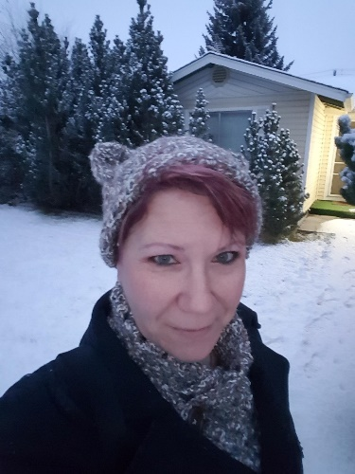
Education for You in 2017

Dott Campo, RHIT
Director of Education

Hello and happy nearly spring. As Ol’ Man Winter slowly and reluctantly releases his grip upon us, we are marching ever forward. Planning for the annual convention continues and is moving along steadily. With the assistance of the Education Committee and many other little helpers peppered throughout Oregon, we finally have gotten the agenda filled. YAY!! It is filled to the brim with a diverse group of people who are excited to present to you all. As with every year, the annual convention will cover a wide range of topics allowing all of us to venture into unknown lands and learn about something new and different.

With the agenda being complete, we are now in the process of getting registration open. Once it is open we will be sending out e-blasts to let you know and reminders to register. Although registration is not open yet, the link for reserving rooms at the Sheraton is live on the OrHIMA website. Grab a room at a great rate while they are available. No matter what speakers we have and how many vendors we have, we do not have a convention without all of you. You all are the reason we hold these events. To bring together our great members from around the state to teach, learn, see old friends and colleagues and make new ones.

Finally, a bit about a fun project in the works. Being this is OrHIMA’s 75th annual convention, we are having some fun gathering old documents, photos and memorabilia from over the years. There is a small committee working to put together an exhibit for the convention to include all of the historical stuff we can find. If you have any of these things, or wish to assist in the creation of this celebration of OrHIMA’s 75 years, please contact me at dlcampo@stcharleshealthcare.org.

Job Board
- Remote Inpatient Coding Specialist – Health Information Associates
- Charge Auditor – St. Charles Health System
To keep up on current postings, check out http://www.orhima.org/him-careers/job-board.

Advocacy – Members as Patients
An Interview with Brian Ahier, Health IT Evangelist

Laurie Miller, RHIT, CCS-P
Advocacy Director

Brian lives in The Dalles, Oregon and has spoken many times for OrHIMA at our Annual Convention and Fall Institute. He is the author of the popular
blog “Advanced Health Information Exchange Resources” and is a nationally – known expert on health information technology. Brian currently works for Aetna as the Director of Standards and Government Affairs at Medicity. He is recipient of Rock Health’s 2017 Digital Health Evangelist Award. I ran into Brian in the Rayburn Building of Washington DC during AHIMA Hill Day 2015. He was on his way to thank Congressman Greg Walden (R-Oregon) for the passage of Medicare Access and CHIP Reauthorization Act (MACRA). That’s just the kind of guy Brian is. I couldn’t think of anyone more connected to the health information profession to interview for our “Members as Patients” campaign.
I shared with Brian the information governance (IG) maturity model stages we identified in our last newsletter. To recall, they are At Risk, Aware, Aspirational, Aligned and Actualized. Brian came up with a sixth marker that I call “Audacious’ where he describes participating as a care team partner, making recommendations, bilateral-sharing of research and sometimes challenging assumptions. “Not every doctor will like this” Brian says, but relayed that an open-minded and wise clinician understands they don’t know everything and can’t keep up with all of the latest literature or disease communities where subscribers worldwide may share treatment resources and success stories. Brian concludes, “this is shared decision making, an outcome of all the stages” of the IG markers.
The topic of patient ownership of our health data ties in here too. Although the patient is unable to tangibly own the data, we as patients can control the data through “shared stewardship” said Brian. My thoughts on stewardship (the careful and responsible management of something) include actions such as managing the accuracy of your health history, medications and allergies, as well as periodically requesting an accounting of disclosures. Regarding the patient data continuum, Brian talks of the future with “patient mediated exchange or a Health Information Exchange (HIE) of One”, a form of personal health record from disparate sources maintained and shared by the patient with whomever he or she wishes and the patient is the co-steward of the medical record with the clinician.
I asked Brian how he thought portal use/patient engagement might be changing or maturing with MACRA. He pointed out the bar for reporting the effort had not changed much from Meaningful Use; mainly having the capacity to fulfill communication. What it will take today is “consumer outreach and patient education efforts” to define why patients should have access to their information and why they should be involved. He notes technology gaps through generations and/or lack of resources as a barrier to outreach.
Brian looks forward to the day when the clinician and patient are equal members of the care team with timely test results (with discretion of course) so we as patients can process results and prepare appropriate questions for the follow up visits. Currently, “even though we may be engaged and empowered, we still can’t bulldoze our way in to be an equal partner in our care.”
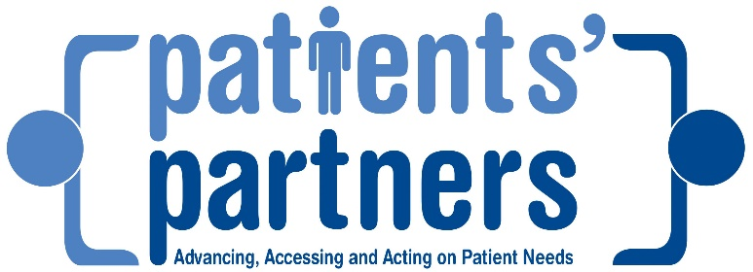
When asked if any sort of repeal of the Affordable Care Act (ACA) would impact public good efforts, Brian references that MACRA and the 21st Century Cures Act (including statutory definition of interoperability) have strong information technology components that an ACA repeal cannot take away.
I asked Brian what he saw as the missed opportunity when patients are not engaged in their personal healthcare. “The problem here if you are not engaged, you are absolved of all responsibility.” A clinician can only do so much with the amount of time in the office and with 99.85% of our time spent outside the healthcare control, often it’s the social determinates of health (#SDoH) that influences our wellbeing.
Thank you Brian for taking some time with OrHIMA regarding our Members as Patients Campaign. We look forward to an opportunity for you to speak at an OrHIMA conference or event.

Patient Involvement – Member Experiences
Pam Yokubaitis, MPH, RHIA, FAHIMA
OrHIMA Past President

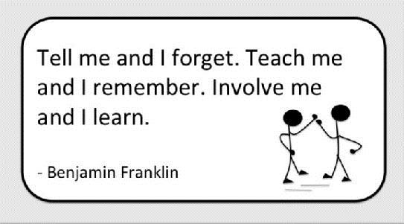
A common problem I see with my husband, and specifically older/geriatric patients in particular, is that they put too much trust in their doctors, relying on them, instead of themselves seeking information and treatment options to become educated about their own illness. This becomes most evident when my husband returns from the doctor and I ask my usual 20 questions and he doesn’t have any answers to any of my questions! As I see it, he doesn’t take full ownership of his own health, so on occasion I have accompanied him to the doctor just to ask all my questions. Sometimes I think he doesn’t know what to ask, and I can tell he believes too much in the doctor and/or system caring for him because he assumes the doctor always knows what to do to help him and he’s willing to take the MD’s comments at face value without further discussion.

With medicine being a drug pushing industry, patients aren’t even questioning the pills/statins/etc. they are being told to take, yet some have been PROVEN to do more harm than good! Pain pills are abused widely, but do MD’s tell patients it’s time you get off them and use natural remedies? Patients don’t push back and say "I won’t take statins"/whatever because they assume their doctor knows best. So, elderly patients GIVE total control to the doctor instead of taking ownership of one’s own health by questioning, challenging, finding other options, etc. Until all patients assume a greater role in educating themselves, they won’t get more involved in their own care.

How do you change this? Patients need to understand that they are the solution to their own problem, and as such, they need to make necessary changes/take ownership of their own problem to fix it. My husband will rely on taking pills because that’s the nature of medicine today, instead of trying to make lifestyle changes to avoid the need to take medications. This is a patient mindset that must first be overcome, before a patient will assume involvement and make lifestyle changes to help them self.

Additionally, many patients think of MDs as Gods because of their extensive training and don’t question them. This patient mindset must also be changed if we want increase patient involvement. Patients need to educate them self about their problem, investigate treatment options, and ultimately approach the doctor with questions about their own findings in order to work as a team to cure them self. If patients viewed doctors as a partner and cheerleader in their healing, rather than the God of cures, AND patients assumed responsibility to make necessary changes (in diet, lifestyle, habits, etc.), then healthcare dynamics would change.

Let’s face it, we get sick because we haven’t properly taken care of ourselves - period. So physicians need to stop being viewed as the savior, and instead need to present themselves as team players with the patient to help the patient change their lifestyle, and be their cheerleader of support. Having migrated to holistic medicine and away from traditional medicine myself, I have learned that the body can heal itself. When my physician administers treatment AND I make necessary lifestyle changes, the outcome is most successful. Good health starts with the realization that it took time to create a problem in our body, so it will take time to reverse the problem. When patients realize that they are a large part of the solution to their own medical problem, many diseases can be eliminated, but it takes the teamwork approach.

Just my two cents….

Bill Watching in Oregon – 2017 Session
Laurie Miller, RHIT, CCS-P
Advocacy Director

Senate Bill (SB) 860 will start the process of requiring insurance companies to reimburse mental health professionals in an equivalent manner to how they reimburse physicians. It will also start the process of ending aggressive or punitive utilizations reviews of mental health services, including over-management and underpayment of CPT 90837 sessions. It will require state enforcement of the existing Oregon Mental Health Parity Law to ensure to Oregon consumers have full access to needed mental health services. The bill has been assigned to the Senate Committee on Human Services. (Extracted from Oregon Independent Mental Health Professionals). Impact includes billing and clinical documentation improvement professionals.
SB397 Directs the Department of Human Services (DHS) to convene a work group to develop a common client confidentiality release form to be used by public bodies and community organizations to enable and facilitate appropriate sharing of confidential information. The bill requires DHS to report to Legislative Assembly during the 2018 regular session and to have release form available for use by July 1, 2018. This bill will impact release of information and patient access departments.
SECTION 3. (1) The Department of Justice shall develop and maintain an information sharing guide setting forth the applicable state and federal laws governing the release of educational, juvenile justice, adult correctional, mental health treatment, substance abuse treatment and health care information. The guide must set forth the applicable laws according to discipline, including but not limited to the release of information by child welfare agencies, law enforcement, juvenile justice agencies, schools, mental health treatment providers, health care providers, substance abuse treatment providers and human services providers.

SB 275 This bill permits covered entities to deny a request for a copy of health information regarding an individual who is appealing denial of Social Security disability benefits if requested by persons other than individual or individual’s personal representative without valid written authorization signed by individual. The bill permits covered entities to charge a reasonable fee for duplicate copies of health information or for health information requested by person other than individual or individual’s personal representative. This bill impacts release of information staff.

SB 816 This bill permits the Oregon Health Authority (OHA) to require hospitals to submit emergency department abstract records, in addition to ambulatory surgery and inpatient discharge abstract records. The bill permits OHA to prescribe by rule abstract record data that hospitals and ambulatory surgery centers must include in records submitted to OHA. It also permits OHA to contract with third parties to compile and process data from abstract records. SB 816 deletes the requirement that OHA reimburse hospitals for the cost of converting records to form specified by OHA if different from the form regularly used by hospital. This bill may impact coding and data extraction departments.

[(7) in addition to the records required in subsection (1) of this section, the authority may obtain Abstract records for each patient that identify specific services, classified by International Classification Of Disease Code, for special studies on the incidence of specific health problems or diagnostic practices. However, nothing in this subsection shall authorize the publication of specific data in a form that allows Identification of individual patients or licensed health care professionals.]

The Risk Adjustment Program – HCC Coding
Monique Vanderhoof, RHIT, CPC, CCA, CRC
RMC, Inc.

Hierarchal Condition Category (HCC) coding plays an increasingly important role in today’s ever-changing world of insurance benefits and reimbursement. With the creation of the Affordable Care Act (ACA), HCC code capture is no longer only for Medicare Advantage plans.

What is Risk Adjustment? -
Risk adjustment payment methodologies mean that insurance companies receive additional reimbursement for the illness burden of a particular patient rather than for quantity of services rendered. Some health plans in turn share this increased revenue with providers. Payments for HCC capture are paid prospectively, so diseases captured this year in 2016 won’t be paid until 2017.
Risk Scoring –
ICD-10-CM codes are translated to one of 79 HCC categories. Not all diagnoses are included in risk scoring, typically the diagnoses involved will be chronic diseases that are costly to care for. For example, diabetes, CHF, COPD, malignant neoplasms, etc. Most acute conditions are not part of risk scoring calculations because they are less costly. However, there are some acute conditions like CVA, MI, hip fracture that are included in the plan. Each diagnosis must only be documented and reported once per year to be included in risk scoring.
Provider Documentation –
Official ICD-9-CM and ICD-10-CM guidelines state that accurate coding cannot be achieved without clear, consistent, complete documentation in the medical record.
Guidelines further instruct to: Code all documented conditions that exist at the time of the encounter, and require or affect patient care, treatment or management
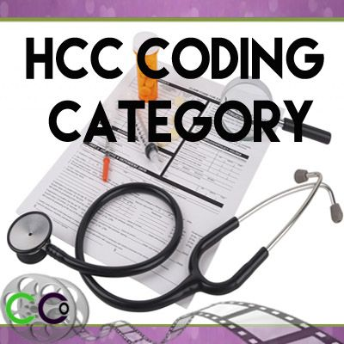
A simple list of problems or diagnoses is not acceptable documentation. Documentation must prove that the patient’s condition(s) were monitored, evaluated, addressed and treated. Additionally, compliant documentation must be legible and include a patient name, date of service and provider signature.
How to ensure proper HCC capture –
ICD-10 brought us increased code specificity and increased requirements for detailed documentation. Work with your providers to make sure that they understand what is required with codes that they commonly use. Make sure that manifestations of certain diseases are not overlooked. For example, when coding diabetic nephropathy (E11.2X), make sure to follow your coding notes and also capture the CKD code (N18.X). Additionally, we see all too often that chronic conditions are note assessed, addressed because the patient only comes in for a specific minor complaint. Chronic conditions that might be managed by a specialist, get completely left out of the PCP documentation. Make sure that your providers are assessing chronic conditions at least once a year as pertinent, so that documentation can be coded for capture of these conditions.
Many times status codes are left off of billings and/or these diagnoses are never assessed. History of amputation, ostomy status, transplant status and dialysis status are all commonly left out of provider assessments. Another commonly forgotten diagnosis is alcoholism; even if in remission, this should be documented when it affects the care of the patient, so that it is codeable and captured.
If it isn’t documented we can’t code it, so ongoing documentation improvement is of utmost importance. RMC offers a wide variety of coding, auditing and education services. If you are interested in knowing more, please let us know!
About Monique –

Monique Vanderhoof, RHIT, CPC, CCA, CRC joined RMC in 2011, and is the Manager of Coding Services. She has over 15 years of experience in health care as a Coding Manager and a Clinic Manager with extensive experience working in outpatient physician settings with an expertise in cardiology. Her skills also include EHR implementation, HIPAA, eRx and Meaningful Use readiness and attestation. Ms. Vanderhoof is an AHIMA approved ICD-10 trainer and is dedicated to preserving coding quality by leading coding education presentations.

AHIMA Survey: Patient Matching Problems Routine in Healthcare
By Julie Dooling, MSHI, RHIA, CHDA; Lorraine Fernandes, RHIA; Annessa Kirby; Grant Landsbach, RHIA; Katherine Lusk, RHIA; Megan Munns, RHIA; Neysa Noreen, RHIA; Michele O’Connor, RHIA, FAHIMA; and Melinda Patten, RHIA, CHPS, CDIP
A recent survey with AHIMA members revealed that over half of HIM professionals routinely work on mitigating possible patient record duplicates at their facility, and of those 72 percent work on mitigating duplicate records weekly. Contributing to the issue, less than half (47 percent) of respondents state they have a quality assurance step in their registration or post registration process, and face a lack of resources to adequately correct duplicates.
In order to learn more about AHIMA members’ experience with patient matching as it relates to linking patient records, an AHIMA membership survey answered by 815 participants using 12 different EHR systems was conducted this summer. AHIMA plans to use the information generated from the survey to help shape its future goals and advocacy efforts in accurate patient matching—an area of HIM it feels can have a significant impact on the care of patients.
Accurate patient matching “underpins and enables the success of all strategic initiatives in healthcare,” according to an AHIMA press release on the survey, including:
- Patient-centric care: Identifiers serve to “link” all patient data. Compromising the “linking” ability compromises care delivery.
- Health information exchange: Correlating patient data across enterprises, regions, or states requires accurate matching of patient data.
- Population health: While population health has many facets, the one common thread is the need to match consumer information at an individual level in order to address the goals.
- Analytics: Identifying best outcomes for patient study groups, identifying consumers across a continuum of care for engagement strategies, and effective research requires accurate patient matching.
- Finance: Value-based purchasing, risk sharing reimbursement models, and accountable care organizations all rely on accurate patient matching across a care continuum.
Information governance encompassing patient matching is essential to successfully executing disruptive and transformational healthcare activities, according to AHIMA officials.
Five Key Survey Findings
The five key finding from the patient matching survey, as well as AHIMA’s analysis on the findings, are:
- Q: Do you measure data quality as it relates to patient matching? A total of 43 percent of respondents are measuring data quality as it relates to patient matching. Routine quality check exercises are an important component of data quality for patient matching. These routine quality checks include examples such as daily, weekly, and monthly reporting on demographic changes made to patients, duplicates created, and feedback mechanisms. The process may also include a reconciliation process for temporary values as indicated with trauma, unknown, and newborn patients.
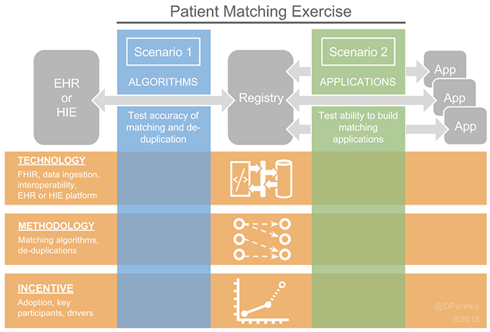
- Q: Do you have a quality assurance step in your registration or post registration? At total of 47 percent of respondent’s state they have a quality assurance step in their registration or post registration process. A robust quality process that provides regular feedback to registration staff improves data quality and one’s ability to match patients internally and externally.
- Q: What is your duplicate medical record number rate in your EHR? When calculating your duplicate rate, what value do you use in the numerator? What value do you use for the denominator? A total of 55 percent of survey respondents were able to communicate the duplicate medical record rate within their organization, but additional questions relating to how the duplicate rate was calculated indicate a lack of a standard definition for duplicate rate calculation. For example, only 42 percent knew the numerator and 42 percent knew the denominator that factored into their organizations duplicate rate.
- Q: Do you work your possible duplicates regularly? If yes, how often? A total of 57 percent of respondents work possible duplicates regularly. Of those respondents, 73 percent work duplicates at a minimum of weekly. Routine, consistent management of identified data integrity issues with clean up in a timely manner are recognized as a necessity by the majority of the respondents
- Q: What kind of challenges do you face on a daily basis with managing your master patient index (MPI) or enterprise master patient index (EMPI)? The top five challenges identified by survey respondents in managing the MPI/EMPI are: Registration staff turnover; record matching/patient search terminology and/or algorithms; lack of resources to correct duplicates; inadequate information governance policy support and lack of executive support. These challenges showcase the diversity and complexities confounding resolution of this key component for sharing information.
How to Improve Patient Matching Initiatives
The authors of the survey said it shows the need to measure, monitor, and inform the marketplace of the need to better match patients to their specific health information. The survey responses illustrate the importance of information governance encompassing patient matching. Accurate patient matching is essential to patient-centric initiatives, and implementing quality assurance measures are critical steps to improving performance, the authors said.
“Reliable and accurate calculation of the duplicate rate is foundational to developing trusted data, reducing potential patient safety risks and measuring return on investments for strategic healthcare initiatives,” the survey authors note.
The Office of the National Coordinator for Health IT’s Report on Accurate Patient Matching, released in February 2014, recommended that organizations move to “prevention” of duplicate record creation versus the current method of back-end data stewardship.
“We cannot sit around and wait for others to correct this problem,” the survey authors said. “As healthcare professionals, we need to embrace the challenge and collaborate to develop scalable solutions to assure patient information is available when and where it is needed.”
AHIMA – What's Ahead for HIM? Look to the Environmental Scan for Answers

Every year, AHIMA produces an environmental scan report investigating the top trends and issues in healthcare, so that we can better understand both what our members and their employers are facing now, and what they should prepare for in the future. The upcoming changes in the report are fascinating reading. They also are important for your career. How will these trends impact you now and in the future? What new opportunities will be open to you? What skills will be outdated?

You can't afford to not know what is in this report. Start with the highlights at the link below.

Read More

A BIG SHOUT OUT TO OUR GOLD & SILVER SPONSORS
Gold
Silver

