**Astro2020 Activities / Projects White Paper**

**Imaging Earth-like Exoplanets with a Small Space Telescope**

**Thematic Areas:** Planetary Systems  Star and Planet Formation

Formation and Evolution of Compact Objects  Cosmology and Fundamental Physics

Stars and Stellar Evolution Resolved Stellar Populations and their Environments

Galaxy Evolution Multi-Messenger Astronomy and Astrophysics

**Principal Author:**

Name: Ruslan Belikov

Institution: NASA Ames Research Center

Email: [Ruslan.belikov@nasa.gov](mailto:Ruslan.belikov@nasa.gov)

Phone: 650-604-0833

**Co-authors and co-signers:** (names and institutions)

Tom Barclay (NASA GSFC), Natalie M. Batalha (UCSC), Eduardo Bendek (NASA JPL), Supriya Chakrabarti (UMass Lowell), Thayne Currie (NASA ARC), Colin Goldblatt (U of Victoria), Olivier Guyon (U of Arizona), N. Jeremy Kasdin (Princeton University), Jim Kasting (Penn State University), Brian D Kern (NASA JPL), Jack J Lissauer (NASA ARC), Julien Lozi (Subaru Telescope), Jared R Males (U of Arizona), Franck Marchis (SETI), Mark S. Marley (NASA ARC), Christian Marois (University of Victoria), Michael W. McElwain (NASA GSFC), Christopher B. Mendillo (UMASS Lowell), Jon A Morse (Boldly Go Institute), Eugene A. Pluzhnik (NASA ARC), Laurent Pueyo (STScI), Billy Quarles (Georgia Institute of Technology), Elisa V. Quintana (NASA GSFC), A J Eldorado Riggs (NASA JPL), Dan Sirbu (NASA ARC), Karl R Stapelfeldt (NASA JPL), Margaret Turnbull (Global Science Institute).

**Abstract.** The Cen AB system represents a particularly attractive target for missions to directly image exoplanets. A potentially habitable planet can in theory be imaged in the system with a telescope as small as 40cm, provided it has a powerful enough starlight suppression system. Technology to enable this is rapidly maturing, and there have been several mission concept studies. This technology is relevant to missions like WFIRST, LUVOIR, and HabEx because it enables them to image binary stars. Small coronagraph mission concepts described here would also complement and synergize with all the above missions. We suggest that a stronger ongoing program is needed, perhaps building on the recent SmallSat concept study initiative, to support mission concept and proposal development for SmallSats ($35M), Missions of Opportunity ($75M) and possibly up through Explorer missions.

# Introduction and Overview of the Alpha Centauri System

The Cen AB system represents a particularly attractive target for missions to directly image exoplanets [1,2], except for the fact that it is a binary system. The A and B stars of the system are Sun-like (G- and K-dwarfs, respectively), and represent unusually favorable “low-hanging fruit” targets that are 3 times easier to observe than the next easiest target by almost any metric (see Figure 1, left). In particular, the next closest star earlier than M-type ( Eri) is 2.4 times as far, and is known to have a thick disk that may interfere with detection of small planets. The next star of comparable proximity to Cen is Barnard’s star, which is 1.4 times farther, has a much dimmer magnitude of 10, and has a habitable zone only 30mas wide, about 30x smaller than Cen. The habitable zones of Cen A and B span stellocentric angles on the order of 1” (see Figure 2). Any given exoplanet imaging telescope can image the planetary system around Cen in at least ~3x higher spatial and spectral resolution (in the photon-noise limited regime) than around any other star, or have at least ~3x SNR for a given spectral resolution. This in particular means that the sensitivity to biomarkers would be much better for planets around Alpha Centauri than for those around any other system.

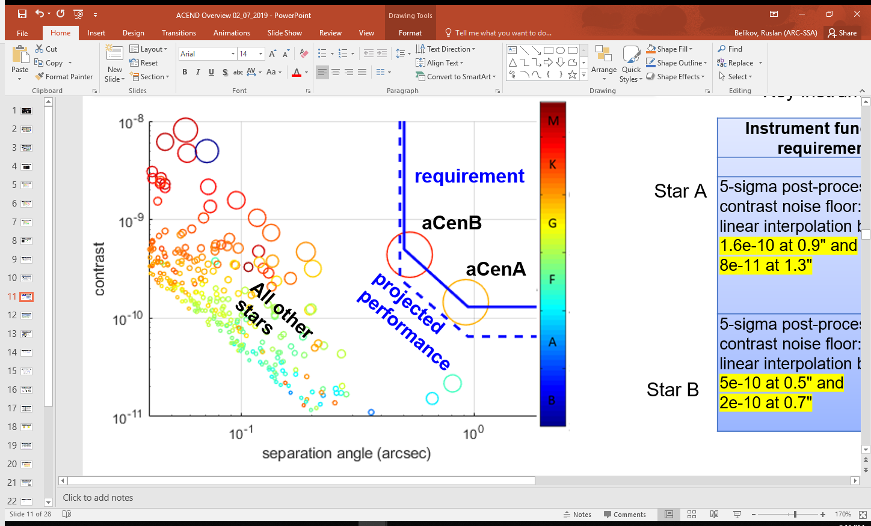 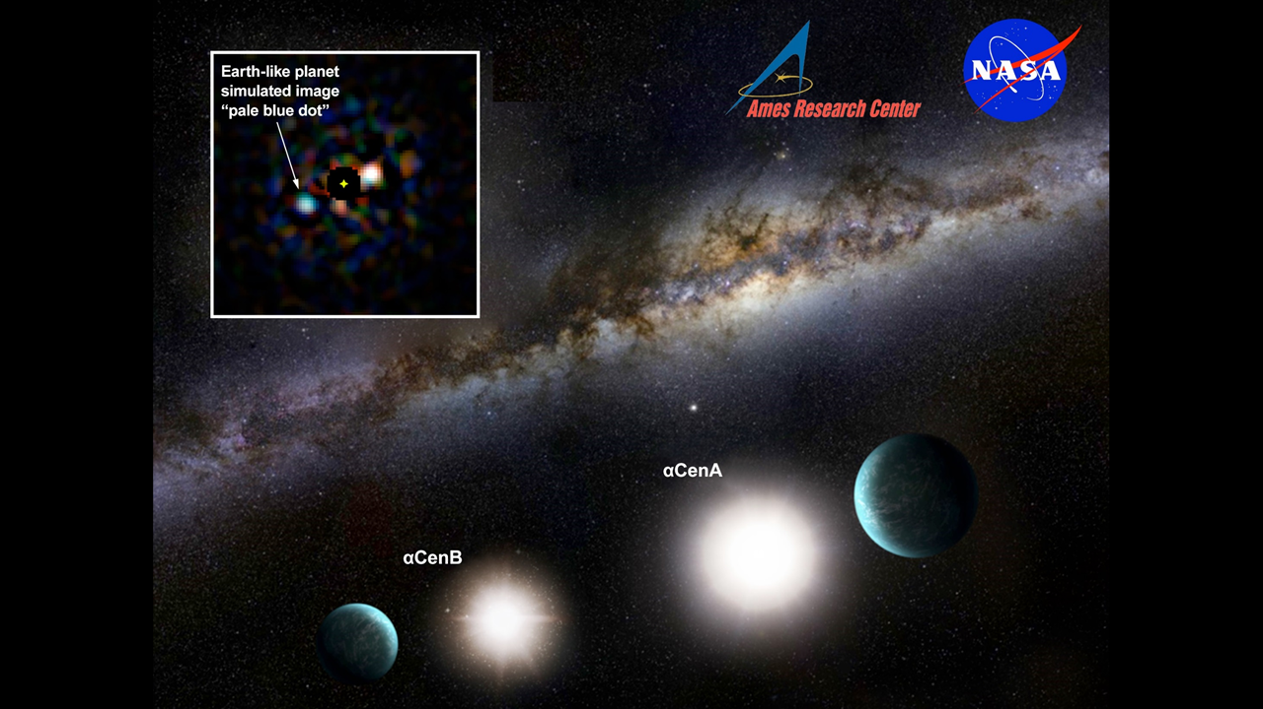

Figure 1. Left: Simulation of a hypothetical Earth twin at quadrature around every nearby star, in reflected light. Circle sizes represent Earth twin apparent magnitude and color represents host star type. Almost any mission can in theory image planets around Alpha Centauri with at least ~3x higher spatial and spectral resolution than for any other star, if it can suppress binary starlight. Right: Simulated image of an Earth twin around  Cen A for the ACESat mission concept (slightly larger than ACEND). Among included effects were zodi, exozodi = 1 zodi, photon noise, telescope jitter.

Furthermore, one of the stars in the system (Cen B) is K-type, with an Earth-twin contrast than can be as high as ~10-9 in the gibbous phase at 0.4”, rather than the 10-10 contrast that is usually quoted for Earth-like planets around Sun-like stars.

Planetary orbits inside 2.5 AU are stable around both stars (e.g. [3,4]). This includes the complete habitable zones around both stars. The probability of planets around stars is challenging to estimate precisely, both because of uncertainties in Kepler mission estimates (e.g. [5-7]), and because of literature disagreement about whether binary stars suppress planet formation or not ([8,9]). Our literature survey indicates that the probability of a potentially habitable planet in the AB system ranges somewhere between 10-80%, and of any type planet between 30-90%. However, a non-detection would still have significant scientific value as shown below.

Theoretically, an Earth twin can be imaged with a telescope as small as 0.25m (25cm) in ~10 hours [2,10], assuming it is equipped with a powerful enough starlight suppression system. Even at that extremely small aperture, an Earth twin will appear 2.7 /D away from the A star at maximum elongation, and have a flux of 1 photon per minute (after accounting for coronagraph and other throughput losses). A larger telescope is necessary to account for current limitations of technology, as well as to have margin. We have studied several small telescope concepts to directly image exo-Earths around Alpha Centauri, including the Alpha Centauri Exoplanet Satellite (ACESat, [10]), Project Blue [11], and the Alpha CENtauri Direct imager (ACEND). These represent different trade points within a family of Cen-imaging small telescopes. Figure 1 (right) shows a simulation of imaging a hypothetical Earth twin around  Cen A with the ACESat mission, a 45cm telescope. Note that since Cen is 1.3pc away, this is in many ways equivalent to a 4.5m telescope imaging a similar system at ~13pc, a representative case for the HabEx mission.

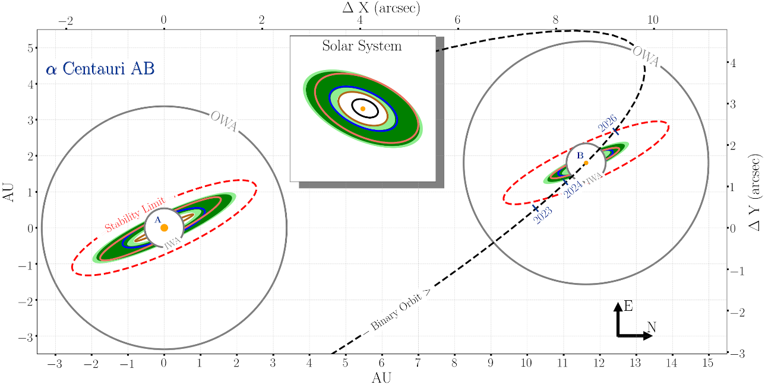

Figure 2. Schematic of the Alpha Centauri AB System. Stars A and B are Sun-like (G-type and K-type, respectively), and are unusually close to our Solar System, enabling a telescope as small as ~40cm to image their habitable zones, which are on the order of 1” in stellocentric angle. The habitable zones of both stars are shown as green bands around both stars. The Solar System is shown, with the size it would appear if it was at Alpha Centauri distance. Colored ellipses around each star show Mercury-, Venus-, Earth-, and Mars- equivalent flux orbits. The “IWA” and “OWA” circles represent the ACESat inner and outer working angles, respectively.

This white paper will focus on the ACEND concept as a baseline, which represents a different point in the trade space than ACESat, and is even lower in cost. However, we emphasize that our family of concepts has several meaningful points in its trade space, and can adapt to shifts in NASA exoplanet science priorities, cost caps, availability of public-private partnerships, and other factors. Most of the general discussions in this paper apply equally well to the entire family.

# Key Science Goals and Objectives

The main goal of ACEND is to directly image and characterize the planetary system of Alpha Centauri A & B, with the capability of recognizing Earth-like planets and assessing their potential for habitability. More specific objectives are summarized in Table 1.

Table 1. Key Science Goals and Objectives of ACEND.

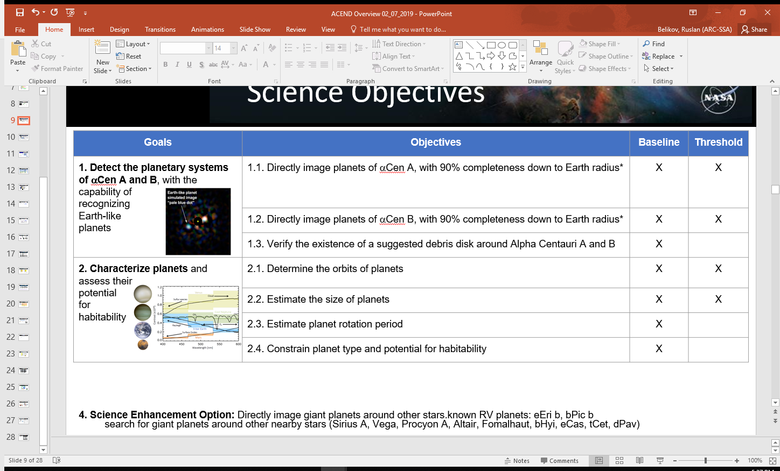

## Description of Data

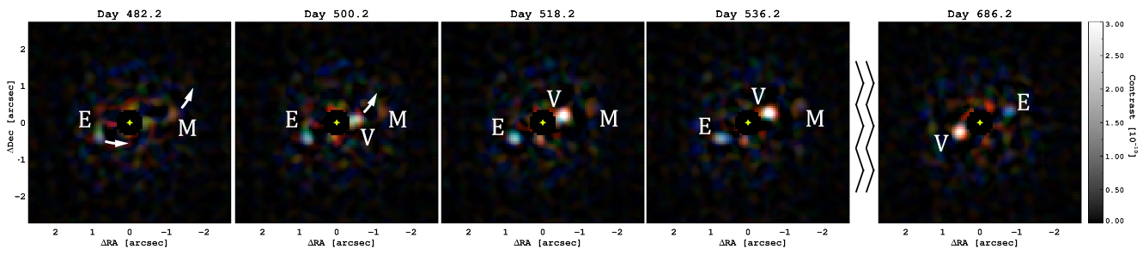

Figure 3. Selected frames from a simulated data sequence showing an orbiting exo-Earth, exo-Venus and exo-Mars. This image sequence was produced for the ACESat mission. The ACEND mission is expected to produce similar images, but only in 3 spectral bands instead of 5.

The final post-processed data will consist of a 2-year long sequence of tens of thousands of high contrast images around each star in 3 bands between 400 and 600nm, with a 20-minute cadence (200 minute cadence per band per star). An example of such a sequence is shown in Fig. 2. By processing this sequence, we will be able to produce complete orbital light curves in 3 bands of all detected planets over a 2-year period (except during the times where a planet is invisible because it is too faint due to crescent phase or inside the inner working angle of the instrument). In addition, we would be able to measure the astrometric position over time.

## Description and Significance of Science Objectives

The detection and characterization of Earth-like planets is one of the most significant goals of NASA’s exoplanet exploration program, and represents one of the most fundamental questions of humanity as a whole. As detailed above, Alpha Centauri represents a particularly attractive opportunity to meet this goal, and ACEND is designed to take maximum advantage of this opportunity at a low cost. Below is a brief summary of the objectives in more detail.

### Planet detection (objectives 1.1, 1.2)

Interest in the Alpha Centauri system has resulted in several observing projects and concepts, including radial velocity and transit searches, direct imaging by ground-based telescopes (GPI, SPHERE), an on-going 10micron campaign from the ground (NEAR, [12]), studies to analyze the feasibility of observing it with JWST, a small astrometry mission concept (Toliman, [13]), and with WFIRST, LUVOIR, and HabEx [14,15]. No confirmed planets have been found to date around either A or B stars, but meaningful limits exist ([16]).

ACEND may or may not be the first to detect a planet or a potentially habitable planet in the system. However, it is unique in that it will image such a planet in blue light, which will add a useful complement to all other observations of that planet, in particular because it will enable measuring Rayleigh scattering in the atmosphere. In the end, to form a truly complete picture of a planet habitability, one needs to combine observations from many different parameters, including mass, orbit, thermal as well as reflected light, in many bands. ACEND will either provide the first detection of at least one of the planets in the system, or provide a critical blue band measurement of it.

### Verifying the existence of a debris disk (objective 1.3)

A 2.5-sigma suggestion of a 100 zodi-level disk around Cen A and B was announced [17]. This does not meet typical standards for a detection, but can serve as a good upper limit for the brightness of zodiacal light in the Cen AB system. If it does exist, such a disk will appear as a ~1e-8 contrast ring on ACEND images. Our post-processing algorithms include Coherent Differential Imaging (CDI) which can subtract stellar speckles from 1e-8 down to about 2e-9 contrast without affecting exozodiacal light, and Orbital Differential Imaging (ODI, [18]), which removes any features that do not appear to move on Keplerian orbits in the images, down to at least 3e-11 contrast. CDI thus enables ACEND to see exozodiacal light at 100 zodi level with an SNR of 5 (and more if it is spatially uniform allowing image smoothing). ODI will remove all of this light, revealing any clumpiness in the exozodi (and planets) that appear to move on Keplerian orbits. Exozodi clumps will be differentiated from planets based on their orbit phase light curves and spectra, avoiding potential confusion between the two.

### Planet characterization (objectives 2.1-2.4)

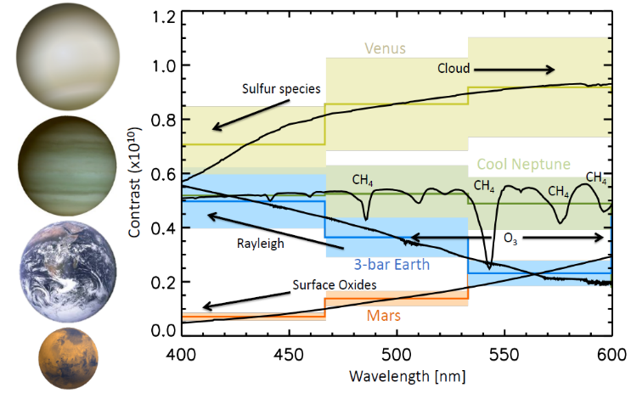The astrometry of planets will enable measurements of a planet’s orbit and the determination of whether it is in the habitable zone. Fourier analysis of light curves will enable measuring the planet’s rotation period as well as weather patterns.

Estimates of planet size or mass are more challenging, but still possible. There is of course a degeneracy between planet albedo and size: a pale blue dot can be an Earth twin, but how do we know it is not a dim Neptune? It turns out that this degeneracy can be significantly addressed, if not completely eliminated, by the data ACEND collects. First, the reflectivity as a function of wavelength can be used to help characterize planet type better, constraining planet size (Figure 4 and Table 2). Second, the observed dynamic range in planet reflectivity over a planet’s orbit and across bands helps constrain planet size, since albedos cannot exceed unity. Third, planet models can be fit to ACEND spectral as well as orbital phase variation data, constraining planet type and albedo further, and thus constraining planet size and mass.

Figure 4. Simulated spectra of several different planet types, integrated over the three ACEND bands. The widths of the bands represent 20% uncertainty. Even with low resolution and noise, many different types of planets can be differentiated.

The visible wavelength range also contains a wealth of information that can be used to characterize exciting types of planets, with several representative examples shown in Table 2. The ACEND blue bandpass can detect signatures of Rayleigh scattering, atmospheric haze, and surface absorption. At red wavelengths, the ACEND filters can show features due to methane and/or water vapor absorption. Clouds, which tend to reflect equally well across all visible wavelengths, will cause flat reflectance spectra across the ACEND bandpasses. Finally, and most excitingly, absorption in the ozone Chappuis band occurs throughout the central ACEND filter. All of these features will be characterized by fitting ACEND observations with spectral models, thereby allowing us to make quantitative estimates of key planetary characteristics, including atmospheric pressure, column depths of water vapor and methane, haze thickness, and presence of biosignature gases. As demonstrated by Fig. 4, a variety of different planetary atmospheric types can be readily distinguished using visible photometry.

**Table 2. Types of planets distinguishable by ACEND.**

|  |  |  |  |  |
| --- | --- | --- | --- | --- |
| **World** | **Characteristics** | **Observables** | **Solar Analog** | **ACEND Observables** |
| habitable planet | surface liquid H2O; gaseous H2O; gaseous CO2 and N2 | Rayleigh scattering; possible H2O features; cloud albedo effects & variability | Earth | increased reflectivity (blue); flat spectrum (green/red); variability |
| true Earth analog | same as "habitable planet"; atmospheric O2 and O3 | same as "habitable planet"; O3 absorption (Chappuis band) | Earth | same as "habitable planet"; broad O3 feature (green) |
| clouded terrestrial | planet-wide cloud; likely gaseous H2O, CO2, and N2 | flat reflectivity; possible H2O vapor and sulfur features | Venus | flat spectrum; possible sulfur feature (blue); H2O feature (red) |
| thin-atmos. terrestrial | lack of clouds; exposed rocky surface; trace CO2 | little Rayleigh scattering; surface oxide absorption in blue | Mars | absorption through blue and green filters |
| hazy terrestrial | haze; atmospheric H2O, CO2, N2, and CH4 | haze absorption in blue; possible H2O and CH4 absorption in red | Titan | haze absorption (blue); possible CH4 absorption (red) |
| thick-CO2 terrestrial | deep atmos.; large amounts of CO2; possible H2O | extensive Rayleigh scattering; possible H2O features in red |  | high reflectivity (blue/green); possible H2O absorption (red) |
| warm gas or ice giant | H2O clouds; gaseous H2O and CH4; possible haze | H2O and strong CH4 absorption; possible haze feature; variability |  | CH4/H2O absorption (red); flat spectrum or haze feature (blue) |
| cool gas or ice giant | haze; ammonia clouds; atmospheric CH4 | haze absorption; strong CH4 absorption; variability | Jupiter  Saturn | Strong CH4 absorption (red); haze absorption (blue) |

### Value of a non-detection

As stated in Section 1, there is a possibility that there will be no potentially habitable planets within the ACEND sensitivity range, or even no planets at all (although the probability of the latter is low). Such non-detections still have significant value, both within the science and programmatic contexts. The science value includes: (a) setting limits on what planets can exist in the system; (b) establishing, with 90% confidence, that the 2 closest Sun-like stars to the Solar System do not contain potentially habitable planets; (c) serving as an important data point for binary planet formation theories. The programmatic value of a non-detection includes the savings from not having to spend LUVOIR or HabEx time looking for planets around Alpha Centauri, as well as savings from not having to require those missions to target 0th magnitude stars and have large outer working angles.

# Value of ACEND to WFIRST, LUVOIR, and HabEx

A small coronagraphic telescope capable of imaging Earth-like planets around Alpha Centauri will also be of significant benefit to WFIRST, LUVOIR, and HabEx. A small telescope can image bands complementary to WFIRST (e.g. blue), which can enable the detection of Rayleigh scattering. Furthermore, although WFIRST is expected to make giant leaps in space-based coronagraphy, it is not currently designed to image Cen. Efforts are under way to enable this, but a specialized smaller telescope specifically designed for Cen may achieve greater sensitivity on that system than a larger general-purpose telescope with many targets. A small mission can also provide characterization targets around Cen for WFIRST, without the need for WFIRST to search for them.

The benefits to LUVOIR and HabEx are even greater, because a small telescope imaging Cen provides significant technology demonstration value in binary star suppression. In terms of angular resolution and photon flux, a small telescope imaging Alpha Centauri is similar to HabEx imaging of a similar star system at around 13pc. Although WFIRST can provide significant technology demonstration value to LUVOIR and HabEx in many critical areas, there are two areas where ACEND can provide unique technology demonstration value: (a) testing coronagraph designs that have performance closer to LUVOIR and HabEx in terms of throughput and inner working angle, than WFIRST’s more mature but older designs; (b) a more thorough / longer test of Multi-Star Wavefront Control than may be possible with WFIRST. The latter in particular is critical to enable LUVOIR and HabEx to take advantage of the greater resolution (in units of AU) and SNR that the aCen system offers, relative to other targets.

Furthermore, ACEND can provide high-value targets for LUVOIR and HabEx, before they are launched, saving valuable search time and increasing the impetus for those missions.

# Technical Overview

Due to space limitations in this white paper, we focus this discussion on the lowest TRL parts of the mission: starlight suppression system and post-processing. The telescope and spacecraft design are of course very important, but are more mature, and are less sensitive to variations in science requirements than the Starlight Suppression System. At least for the case of ACESat, the telescope and spacecraft designs are described in [10]. The ACEND baseline design is a full SiC 40cm off-axis telescope with lambda/25 end-to-end wavefront error. Active thermal control maintains 10C operation with 0.1C PV stability. A Low Order Wavefront Sensor provides 0.5mas stability. The orbit is a LEO sun-synchronous orbit in order to achieve the required thermal stability of the payload. However, orbit and spacecraft trades have not yet been fully closed and require support in order to complete.

## Starlight Suppression System requirements.

We focus the discussion of requirements on what is arguably the most important set of requirements for ACEND: starlight suppression (contrast) and inner working angle, allowing the detection of Earth-like planets. ACEND’s contrast requirement depends on the distance from the star and is shown as a blue curve in Figure 1 (left). 3-sigma contrast needs to be 3x10-10 at 0.4” and 1x10-10 at 1”. Furthermore, this needs to be achieved for a binary star.

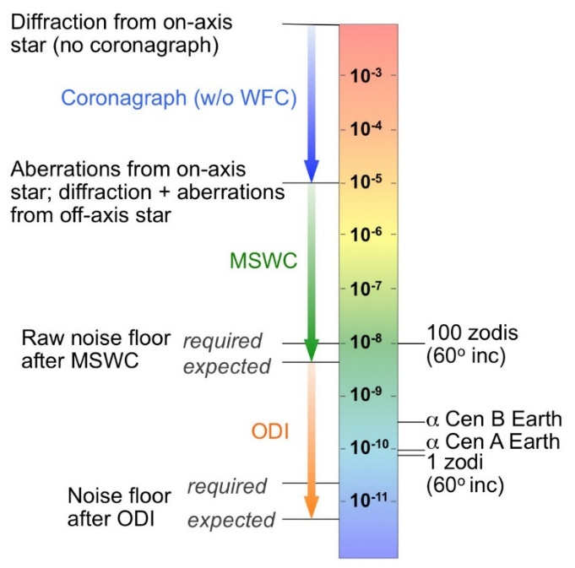Such performance can be enabled by a combination of a high performance PIAA coronagraph (with Vector Vortex as backup), and two relatively new technologies: Multi-Star Wavefront Control (MSWC), which can deliver better than 1e-8 raw contrast in the presence of two or more stars [17, 19], and Orbital Difference Imaging (ODI, [18]), which suppresses contrast noise further in post-processing to at least 3e-11 (1-sigma). Such powerful post-processing is enabled by designing a very stable telescope and collecting 2 years of nearly continuous data on Alpha Centauri. This allows not only significant averaging of random noise, but also accurate calibration of systematics, to a greater degree than possible on missions with multiple targets. In other words, a direct image of an Exo-Earth in reflected light can be achieved at relatively low cost, provided that the mission and the technology is highly specialized for one very favorable target.

Figure 5. Approach to achieving high contrast on a small telescope on a multi-star system with modest raw contrast requirements. The left side shows 1-sigma noise floors.

Note that although ACEND aims for deeper contrast than WFIRST CGI, and at lower cost, it does not outperform WFIRST overall, because WFIRST has many targets, and ACEND only has one. If WFIRST CGI were to adopt the same observing strategy as ACEND (look at Alpha Centauri continuously for 2 years, using Multi-Star Wavefront Control), then we expect it to outperform ACEND. Thus, ACEND and WFIRST form a very complementary pair: a highly specialized low-cost Earth-imager with a blue band on a 40cm telescope, and a general purpose high performance coronagraph on a 2.4m telescope.

There are several astrophysical backgrounds that can potentially interfere or cause confusion for our science objectives. Fortunately, at least a first-order analysis reveals that no background sources cause insurmountable challenges [2]. Contrast of zodiacal light is ~2x10-10. Contrast of exozodiacal light is constrained to be less than ~2x10-8 if Cen has 100 zodis of exozodi (its currently known upper limit). Both will be removed by post-processing as described below. Extragalactic background is extinguished because Cen is in the plane of the Milky Way. Galactic star density is high in the field of Cen and there is a 3% chance of confusion of an exo-Earth with a background star in any one image, but the great proper motion of aCen (4”/year) is enough to eliminate this 3% confusion. In all of these cases, the unusually great apparent brightness of the stars tricks typical astronomical common sense and compensates for the small aperture of the telescope, including having sufficient photon flux from the planet.

## Multi-Star Wavefront Control

Multi-Star Wavefront Control (MSWC, [17, 19]) is an approach to enable high contrast imaging in the presence of two or more stars. The algorithms are currently at TRL3 and funded through TRL4 by the end of 2019. We present a brief summary here.

Mean Contrast: 4.56e-09 
-15 
-10 
10 
15 
20 
-20 -15 -10 -5 0 
-10 
10 15 20 
Sky Angular Separation, Mean Contrast: 2.92e-09 
c -15 
-10 
10 
15 
20 
-20 -15 -10 -5 0 
-10 
10 15 20 
Sky Angular Separation, 

Figure 6. Simulations of MSWC with the ACEND PIAA coronagraph design (baseline, left), and the ACEND Vector Vortex Coronagraph design (backup, right). In both cases, the 1e-8 contrast raw contrast requirement is achieved with good margin. The off-axis star is off the scale at the bottom right.

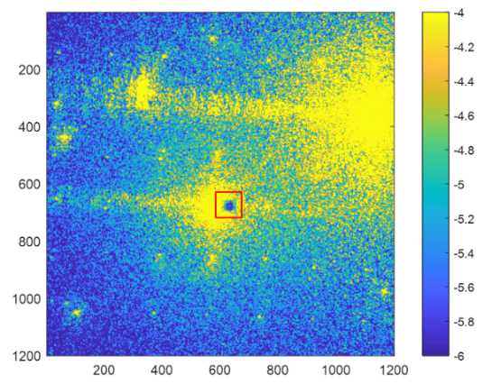 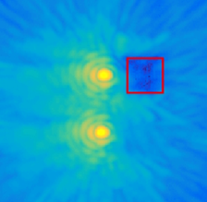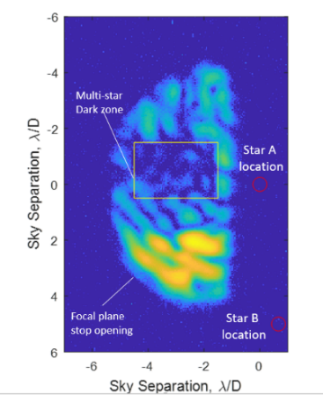

Figure 7. Precursor demonstrations of MSWC on the ACE testbed, showing basic feasibility of MSWC. Left: MSWC-s in monochromatic light without a coronagraph, showing 1e-6 contrast and at least an order of magnitude suppression of speckles from each star (completed APRA work, [18]). Center: preliminary tests of MSWC-0 in broadband light (completed APRA work). Right: preliminary laboratory tests of MSWC-0 with the PIAA coronagraph (ongoing precursor SAT-TDEM work).

MSWC is essentially a wavefront control algorithm, which uses a traditional single-star coronagraph system and computes a special pattern on the deformable mirror to suppress an off-axis star simultaneously with the on-axis one. This approach also requires proper baffling of the off-axis star and a mild grating in the system if the star is beyond the conventional correction region of the deformable mirror. However, it does not require binary coronagraph or any other major changes to existing mature starlight suppression system designs.

A simulation of a single raw ACEND image with MSWC is shown in Figure 6 (for the baseline PIAA coronagraph case as well as the Vector Vortex design, in a 14% ACEND band). In both cases, the ACEND raw contrast requirement of 10-8 is met.

Laboratory testing of MSWC has started at the Ames Coronagraph Experiment (ACE) testbed [19]. Initial tests are shown in Figure 10, showing the validity of the basic principle behind MSWC: the ability to independently suppress speckles from two stars. However, more work is required to bring this technology to contrast levels required by ACEND in broadband light, as well as to demonstrate it in vacuum.

## Orbital Differential Imaging

The main feature of Orbital Differential Imaging is that it leverages a large number of images spanning a significant portion of a planet’s orbit to extract the planet signal (see Figure 8). This is motivated by two basic principles: (a) signal to noise grows with number of images (at least in the case where the noise is uncorrelated between images); and (b) planets move on Keplerian orbits, so any “speckles” in the image sequence that does not move on a Keplerian orbit can be filtered out (including stationary exozodiacal light). In this section we cover the basic principles, but as shown in a more detailed treatment [18], it appears that at least for some range of assumptions about the nature of noise and systematic errors, factors of 1000 gains in post-processing appear to be possible with this technique (for missions that deliver the requisite long image sequence).

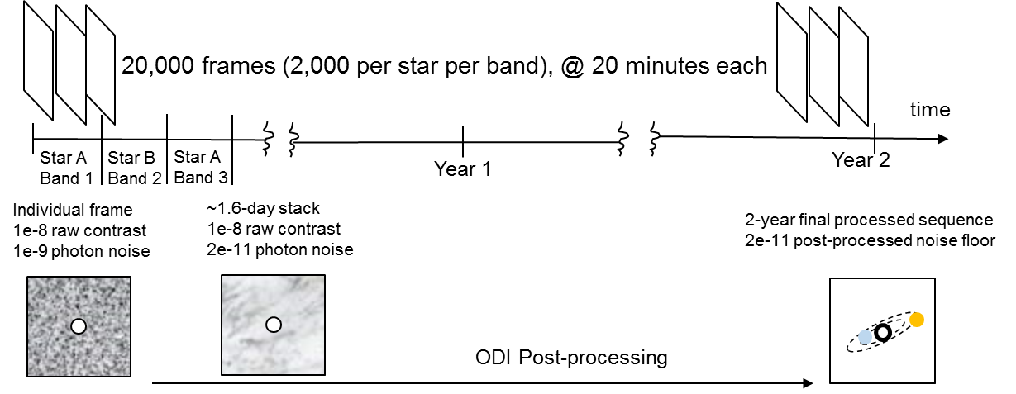

Figure 8. The proposed post-processing technique (orbital difference imaging) leverages the large number of images collected by spending months or years on a given star to obtain much deeper contrast gain in post-processing than is possible on a single visit.

Figure 8 shows a simple calculation of how this technique can work on a small telescope. The numbers were computed for the case of a 45cm telescope and depend on telescope size, bandwidth, system throughput, etc., but the order of magnitude of the numbers remains the same for a wide range of parameters. 20-minute frames spanning 2 years would result in a total of 20,000 frames (10,000 per star). Assuming a 10% end-to-end system throughput, the photon noise of a 10-8 contrast speckle will be ~10-9. A ~2-day stack will reduce the photon noise to ~2x10-11, so that if the speckle field was perfectly calibrated and known, a 2-day stack of images is sufficient to see a 10-10 contrast planet at SNR=5. Processing the entire sequence as described in [18] effectively enables the calibration of this field on every 2-day image (though this is treated implicitly in the actual algorithm), revealing planets.

A simulation of ODI is shown in Figure 3, for the case of ACESat. This simulation assumed 5 bands (and other parameters of the mission concept described in the next section), and a post-MSWC raw contrast of 10-8 at the inner working angle. For this sequence, we assumed an Earth-like, Venus-like, and “Pseudo-Mars” planet (at 2.5 AU and Earth-sized). Earth- and Venus-like planets can be seen orbiting the star in the processed sequence. An additional “shift-and-add” technique can be used to further boost signal to noise, where images are shifted and co-added along candidate signal’s orbit to further boost SNR. This can recover fainter planets that are not readily apparent on the processed sequence, such as pseudo-Mars.

# Key remaining challenges and requests from committee

We have focused this white paper on the science and starlight suppression technologies of ACEND rather than a comprehensive mission concept that closes, because MSWC and post-processing are arguably the least mature technologies in the mission concept, and their maturation represents key remaining challenges for ACEND. However, even though the remaining parts of the mission do not involve low-TRL technologies, they still require design, trades, costing, and overall closing of the mission concept. A key third challenge of ACEND is to bridge the gap from the study of starlight suppression systems and TRL advancement to a full mission concept study that closes.

### Maturation of MSWC

The maturation of MSWC is currently being supported by the NASA Internal Scientist Funding Model (ISFM) program (within the context of WFIRST, LUVOIR, and HabEx). Although there is no guarantee that it will continue being supported, it is (a) within the scope of ROSES proposals; (b) is recognized as relevant to NASA’s strategic missions.

### Orbital Differential Imaging

Orbital Differential Imaging is within the scope of what can be proposed to ROSES, or as part of Phase A/B technology development on a mission proposal, but is not widely recognized as being relevant to NASA’s strategic missions because they are not designed to spend a lot of time on any one target. In today’s environment, it is challenging to develop technologies that are critical for competed missions but are not critical for strategic missions. An initiative to enable support for such technologies will help advance cutting-edge technologies that are useful for small missions but that do not necessarily tie strongly into strategic missions.

### Bridging the gap to full Mission Concept Design

Within the ACEND family of designs, only ACESat enjoyed the support and a comprehensive mission design study required to produce a full mission proposal. ACESat was a SMEX-class concept ($173M in 2014), but the latest advances in coronagraph technology as well as the evolved scientific landscape potentially make a down-scoped and lower cost mission like ACEND more attractive.

However, in order to realize this promise, substantive financial support is required in order to drive the concept from a 10-page white paper to a competitive proposal. We have supported important technology development through a combination of NASA grants and private funding. However, we suggest that an ongoing program is needed, perhaps building on the recent SmallSat concept study initiative, to support mission concept and proposal development for SmallSats ($35M), Missions of Opportunity ($75M) and possibly up through Explorer missions, which would likely improve the technical and cost fidelity of future proposals in this cost regime. It may also be beneficial to facilitate international workshops that could highlight overlapping scientific interests and cost-sharing opportunities for small-scale missions.

# References

1. Belikov, R., et al., “Direct Imaging of Exoplanets in Nearby Multi-Star Systems,” *Astro2020 science white paper* (2019).
2. Belikov, R., Bendek, E. A., Thomas, S., J., Males, J. R., Lozi, J., “How to directly image a habitable planet around Alpha Centauri with a ~30-45cm space telescope,” *Proc SPIE* 9605-41, (2015).
3. Weigert, J., Liseau, R., Thebault, P., Olofsson, G., Mora, A., Bryden, G., Marshall, J.P., Eiroa, C., Montesinos, B., Ardila, D., Augereau, J.C., Bayo Aran, A., Danchi, W.C., del Burgo, C., Ertel, S., Fridlund M.C.W., Hajigholi, M., Krivov, A.V., Pilbratt, G.L., Roberge, A., White, G.J., Wolf, S., “How dusty is alpha Centauri? Excess or non-excess over the infrared photospheres of main-sequence stars,” *A&A 563*, (2014).
4. Quarles, B., Lissauer, J. J., “Long-term Stability of Planets in the aCentauri System,” *AJ 151, 5* (2016).
5. Bryson, S., Coughlin, J., Batalha, N. M., Berger, T., Huber, D., Burke, C., Mullally, S. E., “A Probabilistic Approach to Kepler Completeness and reliability for Exoplanet Occurrence Rates,” *in prep*, (2019). <https://arxiv.org/abs/1906.03575>.
6. Burke, C. Christiansen, J.L., Mullally, F., et al., “Terrestrial Planet Occurrence Rates for the Kepler GK Dwarf Sample,” *ApJ 809, 1* (2015).
7. Belikov, R., and the SAG13 team, “Exoplanet Occurrence Rates and Distributions,” *ExoPAG SAG13 study* (<https://exoplanets.nasa.gov/exep/exopag/sag/#sag13>).
8. Kraus, A. L., Ireland, M. J., Huber, D., Mann, A. W., Dupuy, T. J., “The Impact of Stellar Multiplicity on Planetary Systems. I. The Ruinous Influence of Close Binary Companions,” *AJ 152,* 1 (2016).
9. Matson, A. R., Howell, S. B., Horch, E. P., Everett, M. E., “Stellar Companions of Exoplanet host Stars in K2,” *AJ 156, 1* (2018).
10. Bendek, E.A., Belikov, R., Thomas, S.J., Lozi, J., Males, J.R., “Space telescope design to directly image the habitable zone of Alpha Centauri,” *Proc SPIE 9605-40*, (2015).
11. Morse, J., Bendek, E., Cabrol, N., Marchis, F., Turnbull, M., Chakrabarti, S., Fischer, D., Goldblatt, C., Guyon, O., Hart, M., Males, J., Kasting, J., “Project Blue: Visible Light Imaging Search for Terrestrial-class Exoplanets in the Habitable Zones of Alpha Centauri A and B,” *White paper submitted to the Exoplanet Science Strategy study of the National Academies of Sciences, Engineering and Medicine.* (2019). ([https://arxiv.org/abs/1803.04872](https://urldefense.proofpoint.com/v2/url?u=https-3A__arxiv.org_abs_1803.04872&d=DwMFAg&c=ApwzowJNAKKw3xye91w7BE1XMRKi2LN9kiMk5Csz9Zk&r=CQS6VIcU4-SST8cLvtsrgzws1e70VA04cGyn9hjCO-o&m=q_HDikg8q9jmuif03twLH7SX4VSKDVzTETh0kIFzr8E&s=x0zX2CNLiJUtyOvtzNRqUaJzdHw5zw7Uo7tKCucDK9c&e=))
12. <https://www.eso.org/public/news/eso1702/>
13. Tuthill, P., Bendek, E., Guyon, O., Horton, A., Jeffries, B., Jovanovic, N., Klupar, P., Larkin, K., Norris, B., Pope, B., Shao, M., “The TOLIMAN space telescope,” *Proc SPIE 10701*, (2018).
14. Sirbu, D., Belikov, R., Bendek, E., Henze, C., Riggs, A.J., “Multi-star wavefront control for the wide-field infrared survey telescope,” *Proc SPIE 10698* (2018).
15. Sirbu, D., Thomas, S., Belikov, R., Bendek, E., "Techniques for High-contrast Imaging in Multi-star Systems II. Multi-star Wavefront Control," *ApJ849*, 2 (2017).
16. Zhao, L. L., Fischer, D., Brewer, J. M., Giguere, M., Rojas-Ayala, B., “Planet Detectability in the Alpha Centauri System,” *ApJ 155, 1* (2018).
17. Weigert, J., Liseau, R., Thebault, P., Olofsson, G., Mora, A., Bryden, G., Marshall, J.P., Eiroa, C., Montesinos, B., Ardila, D., Augereau, J.C., Bayo Aran, A., Danchi, W.C., del Burgo, C., Ertel, S., Fridlund M.C.W., Hajigholi, M., Krivov, A.V., Pilbratt, G.L., Roberge, A., White, G.J., Wolf, S., “How dusty is alpha Centauri? Excess or non-excess over the infrared photospheres of main-sequence stars,” *A&A 563,* (2014).
18. Males, J., Belikov, R., Bendek, E.A., “Orbital difference imaging: a new high-contrast post-processing technique for direct imaging of exoplanets,” *Proc SPIE 9605-42*, (2015).
19. Belikov, R., Pluzhnik, E., Bendek, E., Sirbu, D., "High Contrast Imaging in Multi-Star Systems: Progress in Technology Development and Lab Results," *Proc SPIE 10400* (2017).