**Astro2020 Science White Paper**

**Understanding the Origin and Impact of Relativistic Cosmic Particles with Very-High-Energy Gamma-rays.**

**Thematic Areas:** Planetary Systems  Star and Planet Formation

Formation and Evolution of Compact Objects  Cosmology and Fundamental Physics

Stars and Stellar Evolution Resolved Stellar Populations and their Environments

Galaxy Evolution Multi-Messenger Astronomy and Astrophysics

**Principal Author:**

Name: Jamie Holder, University of Delaware, jholder@physics.udel.edu, 302 8313421

**Co-authors:**

E. Amato (INAF, Obs. Arcetri, Italy), R. Bandiera (INAF, Obs. Arcetri, Italy), R. Bird (UCLA), A. Bulgarelli (INAF/OAS, Bologna, Italy), V. V. Dwarkadas (U. Chicago) , N. Giglietto (INFN, Politecnico di Bari, Italy), P. Goldoni (APC/U. Denis-Diderot, France), J. Hinton (MPIK, Germany), B. Hnatyk (National U. Kyiv, Ukraine), T. B. Humensky (Columbia U.), S. Inoue(RIKEN, Japan), P. Kaaret (U. Iowa), J-P. Lenain (LPNHE/Sorbonne U., France), A. Marcowith (LUPM, U. Montpellier), G. Morlino (INAF, Obs. Arcetri, Italy), R. Mukherjee (Barnard/Columbia U.), S. Ohm (DESY, Germany), A. Pe'er (Bar-Ilan U., Israel), R. A. Ong (UCLA), M. Ostrowski (Jagiellonian U., Poland), M. Santander (U. Alabama), O. Sergijenko, (National U. Kyiv, Ukraine), L. Tibaldo (IRAP, Toulouse, France), D.F. Torres(ICE, CSIC/IEEC/ICREA, Barcelona, Spain), N. F. H. Tothill (Western Sydney U., Australia), J. Vandenbroucke (U. Wisconsin), S. Vorobiov (U. Nova Gorica, Slovenia), D. Williams (UC Santa Cruz)

On behalf of the CTA Consortium.

https://www.cta-observatory.org/about/cta-consortium/

**Abstract**:

This white paper briefly summarizes the importance of the study of relativistic cosmic rays, both as a constituent of our Universe, and through their impact on stellar and galactic evolution. The focus is on what can be learned over the coming decade through ground-based gamma-ray observations over the 20 GeV to 300 TeV range. The majority of the material is drawn directly from “Science with the Cherenkov Telescope Array” [1], which describes the overall science case for CTA. We request that authors wishing to cite results contained in this white paper cite the original work.

**Introduction**

Relativistic particles play a major role in a wide range of astrophysical systems, from pulsars and supernova remnants in our own Galaxy, to active galactic nuclei and clusters of galaxies. Within the interstellar medium of our Galaxy, these ‘cosmic rays’ are close to pressure equilibrium with interstellar gas and magnetic fields – yet the relationship between these three components, and the overall impact on the star-formation process and the evolution of galaxies, is very poorly understood.

In the coming decade, ground-based observatories have the potential to provide high-angular resolution measurements of cosmic-ray protons and nuclei in astrophysical systems, through the non-thermal gamma-ray emission which results from the interactions of these cosmic rays with matter and photon fields. This is in addition to gamma-ray emission associated with the energetically sub-dominant electrons, that also produce the non-thermal emission seen at radio and X-ray wavelengths. These observations will provide insights into the mechanisms of cosmic ray acceleration, transport, and feedback, thus making a major contribution to our deepening understanding of the processes by which galaxies and clusters of galaxies evolve.

Below we introduce the main elements of this theme, beginning with the accelerators themselves, and then moving to the wider impact of the accelerated particles. While we focus here on the scientific goals, and the observations required to achieve them, progress in this field over the coming decade will inevitably be dominated by the development of the Cherenkov Telescope Array (CTA), a major new international observatory for GeV-TeV gamma-ray astronomy [2]. CTA will be presented in detail in a forthcoming APC white paper.

**Cosmic Accelerators**

The primary goal of gamma-ray astrophysics thus far has been to establish in which cosmic sources particle acceleration takes place and, in particular, to determine the dominant contributors to the locally measured cosmic rays, which are 99% protons and nuclei. Huge progress has been made over the last decade in this area, with the combination ofspace-based and ground-based observations proving extremely effective in identifying the brightest Galactic accelerators, and providing strong evidence of hadron acceleration in a handful of sources. However, key questions remain unanswered: are supernova remnants (SNR) the only major contributors to the population of Galactic cosmic rays? Where in our Galaxy are particles accelerated up to the highest (PeV) energies? What are the sources of high-energy cosmic electrons? What are the sources of the ultra-high energy cosmic rays?

These questions, along with the critical issue of the dominant *mechanisms* for cosmic ray acceleration, can be addressed over the coming decade through two main approaches:

(i) a census of particle accelerators in the Universe, achieved through sensitive Galactic and Extragalactic surveys in the 20 GeV - 300 TeV gamma-ray band, and

(ii) precision gamma-ray measurements of archetypal sources, where bright nearby sources will be targeted to obtain spatially-resolved spectroscopy, or very high statistics light curves, to provide a deeper physical understanding of the processes at work in cosmic accelerators.

A general census is required to understand the populations of cosmic ray accelerators and the evolution and lifecycle of these source classes - existing population studies in the TeV band are currently limited to typically only tens of objects [3] [4]. Complementary deep observations of individual sources will provide the very broad band spectra and high angular resolution images which allow to unambiguously separate lepton and hadron acceleration, and to test acceleration to the highest energies possible for Galactic accelerators.

The census of particle accelerators in our Universe is best achieved by performing surveys of the sky at unprecedented sensitivity in the >20 GeV energy band. CTA can deliver these surveys with one to two orders of magnitude better sensitivity than existing surveys, very early in the life of the Observatory. Indeed, over much of the sky, and over much of the energy range of CTA, no survey exists, and the CTA measurements will be revolutionary. The observations will open up discovery space in an unbiased way and generate legacy datasets of long-lasting value. The planned survey regions include an extragalactic survey, covering ¼ of the extragalactic sky to a depth of 6 mCrab, and a Galactic Plane survey, with sensitivity sufficient to detect essentially the entire Galactic population of luminous (>1034erg/s) TeV sources, and to provide a large sample of objects up to one magnitude fainter (Fig. 1). In addition, a survey of the Large Magellanic Cloud (LMC) will provide a face-on view of an entire star-forming galaxy, resolving regions down to 20 pc in size. This will allow to map the diffuse LMC emission as well as individual objects, thus providing key information on relativistic particle transport.

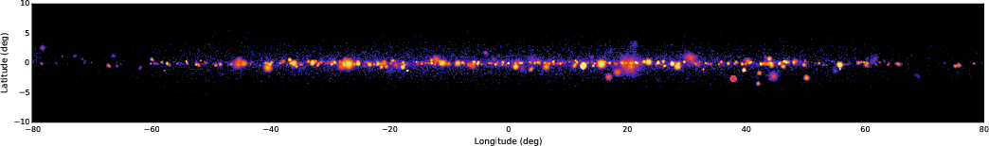

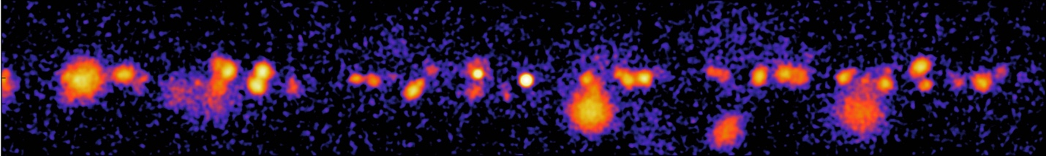

**Figure 1:** *Top*: a simulated CTA image of the inner region of the Galactic Plane. *Bottom*: A zoom of a typical 20 $°$ region of Galactic longitude.

The Galactic Plane survey will provide a complete and systematic view of the Galaxy, greatly increasing our understanding of both the Galactic source populations and the diffuse emission components. It is expected to increase the catalog of known Galactic sources by a factor of 5 or more, to of order 300-500 objects, primarily pulsar wind nebulae and supernova remnants. As well as enabling comprehensive population studies of these source classes, it will reveal new and unexpected phenomena, new source classes and new forms of transient behavior, and identify candidates for the sites of acceleration of the highest energy Galactic cosmic rays. These observations will address questions of how and where protons and nuclei are accelerated to PeV energies, how particles are accelerated in relativistic shocks and, to some extent, how cosmic rays impact the interstellar medium as they propagate. A deeper exposure of the inner few degrees around the Galactic Center will finally reveal the nature of the point-like central gamma-ray source, probably (but not certainly) associated with the supermassive black hole Sgr A*. Particle acceleration in the vicinity of the Galactic Center will be explored by studying the diffuse gamma-ray emission along the Galactic Center ridge, which extends over 1.5 degrees along the Galactic plane and is generally acknowledged to be generated by hadronic interactions [5].

The extragalactic survey will provide an unbiased population study of the local Universe (*z*<0.2) in the energy range from 100 GeV to 10 TeV. Sources in quiescent as well as flaring states will be detected, and will provide an unbiased determination of the luminosity function (log *N* – log *S* distribution) for gamma-ray emitting active galactic nuclei. This will be the first time that a such a large portion (25%) of the sky is observed uniformly with high sensitivity at these energies, which will very likely lead to the serendipitous detection of rapid flares, and the discovery of gamma-ray emission from as yet undetected source classes such as Seyfert galaxies.

To complement these surveys, deep observations of individual sources will be performed which will have a transformational impact on our understanding over the coming decade. Objects to be targeted include supernova remnants, pulsar wind nebulae and their extended TeV haloes, gamma-ray binaries, colliding-wind binaries, massive stellar clusters, starburst galaxies and active galaxies. Along with targets selected from the existing TeV catalogs, the aforementioned surveys will provide a list of promising objects for deeper follow-up observations. In particular, the performance of CTA at the highest energies, above 20 TeV, will allow to identify and study potential Galactic PeVatrons – objects capable of accelerating cosmic rays up to the PeV scale, in which the problematic ambiguity between leptonic and hadronic origin is almost completely resolved. There is also huge potential for the discovery of new *classes* of accelerators, with emission from clusters of galaxies as one of the most exciting possibilities.

As an example, simulated gamma-ray observations of the bright, young supernova remnant (SNR) RX J1713.7-3946 are shown in Figure 1. The dominant gamma-ray emission mechanism is unclear from current measurements [6] [7], but future measurements will resolve the ambiguity between lepton- and hadron-dominated emission and resolve sub-structure within the SNR shell on scales that are important for our understanding of the acceleration process.

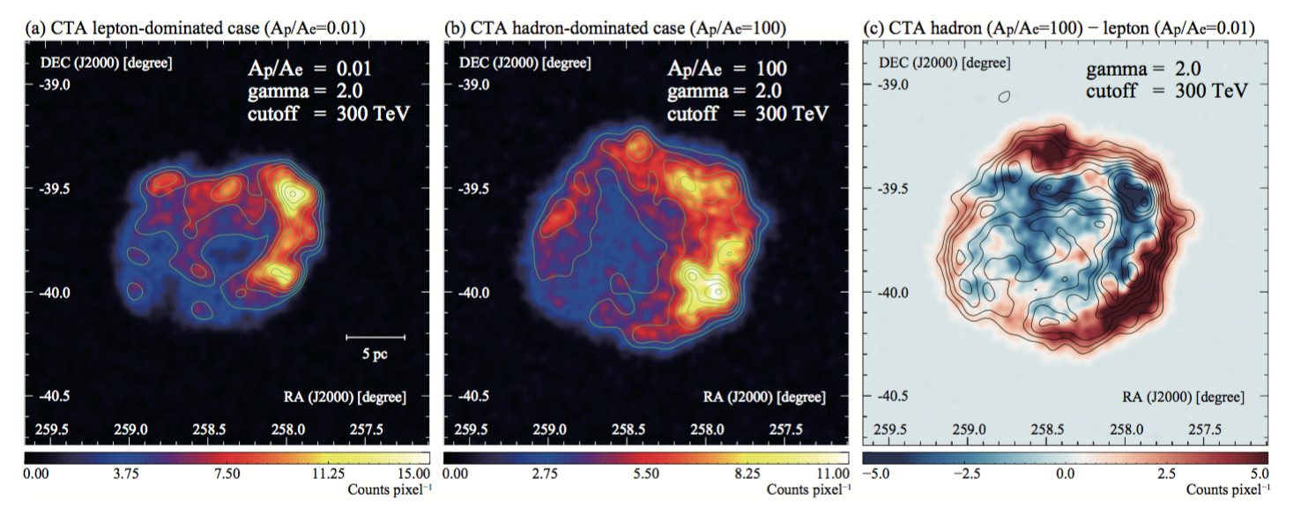

Figure 1 – Simulated CTA images of the TeV-bright supernova remnant RX J1713.7-3946 for different emission scenarios, showing the potential of CTA to differentiate between these scenarios. Reproduced from [8].

**Propagation and Influence of accelerated particles**

Beyond the question of how and where particles are accelerated in the Universe, is the question of what role these particles play in the evolution of their host objects and how they are transported out to large distances. On the scale of clusters of galaxies, cosmic rays with TeV–PeV energies are thought to be confined over a Hubble time [9]. On smaller scales, they typically escape from their acceleration sites and may impact their environments in a number of ways:

(i) as a dynamical constituent of the medium,

(ii) through generation / amplification of magnetic fields, and

(iii) through ionization and subsequent impact on the chemical evolution of (for example) dense cloud cores – since cosmic rays are able to penetrate deep inside molecular clouds.

All of these effects are relevant for the interstellar medium of our own Galaxy and are likely to be important in star-forming systems on all scales. The first aspect is also likely to be important for the process of AGN feedback on the host galaxy cluster and growth of massive galaxies.

CTA will map extended emission around many gamma-ray sources and look for energy dependent morphology associated with diffusion (in the case of hadrons) or cooling (in the case of electrons). As the energy dependence is expected to be opposite in the two cases, such mapping provides another means, in addition to spectral studies, to separate the emission from these two populations. It is CTA’s unprecedented (in the gamma-ray domain) angular resolution, energy resolution and background rejection power that will make this possible.

Among the targets are star-forming systems – both star-forming regions within our Galaxy and the LMC, as well as nearby spiral and starburst galaxies. Observations with CTA will probe the relationship between star formation and particle acceleration in these systems. As an example, Figure 2 shows simulated images of the Westerlund 1 star forming region in three different energy bands. CTA will be able to detect energy-dependent morphology, resolve substructures, and probe cosmic ray propagation in such regions.

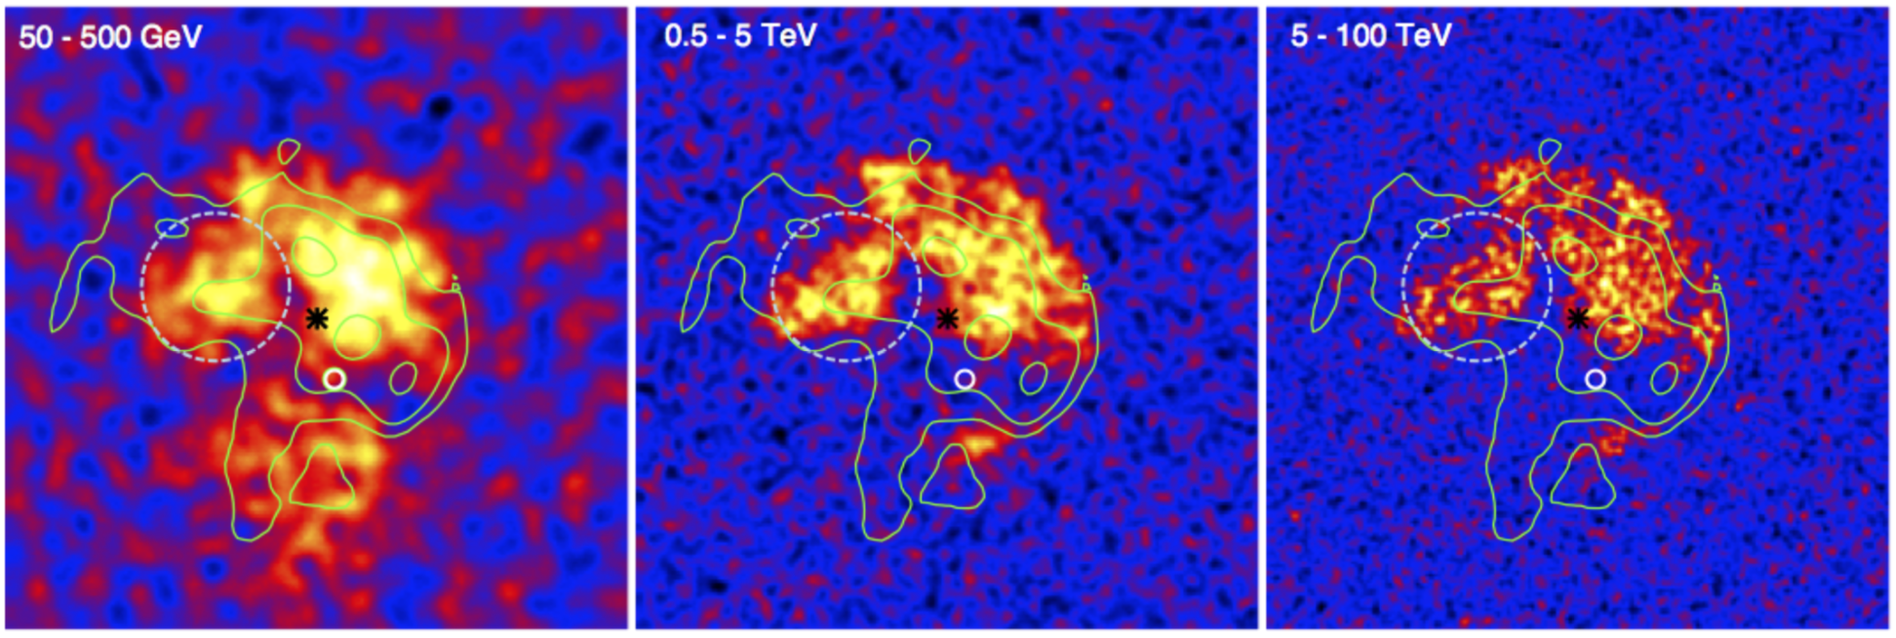

**Figure 2:** Simulated Westerlund 1 gamma-ray excess maps for CTA in three different energy bands, smoothed with the CTA point spread function. H.E.S.S. contours are shown in green, the black star indicates the optical stellar cluster and the magenta circle is the Fermi-LAT-detected PSR J1648-4611. The light blue dashed circle shows the star-forming region G 340.2-0.2.

On the scale of individual galaxies, the LMC provides a unique target hosting a number of extraordinary objects, including 30 Doradus - the most active star-forming region in the local group of galaxies, the super star cluster R136, supernova SN1987A and the 30 Dor C superbubble. It is one of the nearest star-forming galaxies, with one-tenth of the star formation rate of the Milky Way distributed in only two percent of its volume. Since it is observed face-on, at high Galactic latitudes, observations of the LMC will provide a well-resolved global view of a star-forming galaxy at very high energies, allowing to study the transport of cosmic rays from their release into the interstellar medium to their escape from the system. Nearby spiral, starburst and ultra-luminous infrared galaxies (ULIRGs) provide additional galaxy-scale objects for cosmic ray studies. The enhanced rate of star formation in these systems is expected to lead to intense cosmic ray production through associated supernovae - in an extreme object such as the nearby ULIRG Arp 220, a supernova explosion is expected to occur once every 6 months [10], as compared to roughly once per century in our own Galaxy. This is coupled with an enhanced density of low energy photons and interstellar material to act as targets for gamma-ray production mechanisms from both leptonic and hadronic cosmic rays.

On the largest scales, the most massive gravitationally bound systems in the Universe - galaxy clusters – are expected to be reservoirs of cosmic rays accelerated both by structure formation processes, and by their constituent galaxies and active galactic nuclei. Cosmic ray protons in the intra-cluster medium should accumulate over cosmological timescales [9] [11], leading to subsequent gamma-ray emission. To date, no Galaxy clusters have been detected in gamma-rays but, based on theoretical studies and hydrodynamical simulations, the Perseus cluster should be the brightest target, detectable with CTA. Deep observations of Perseus with CTA will determine the cosmic ray proton content of clusters and measure its impact on the cluster environment.

# References

|  |  |
| --- | --- |
| [1] | The CTA Consortium, Science with the Cherenkov Telescope Array, World Scientific, 2019. |
| [2] | B.S. Acharya, et al., "Introducing the CTA Concept," *Astropart. Phys,* vol. 43, p. 3, 2013. |
| [3] | The H.E.S.S. Collaboration, "The population of TeV pulsar wind nebulae in the H.E.S.S. Galactic Plane Survey," *A&A,* vol. 612, p. 25, 2018. |
| [4] | The H.E.S.S. Collaboration, " Population study of Galactic supernova remnants at very high gamma-ray energies with H.E.S.S.," *A&A,* vol. 612, p. 3, 2018. |
| [5] | F. Aharonian, A.G. Akhperjanian, R. Bazer-Bachi et al., "Discovery of very-high-energy γ-rays from the Galactic Centre ridge," *Nature,* vol. 439, p. 695, 2006. |
| [6] | S. Gabici and F. A. Aharonian, "Hadronic gamma-rays from RX J1713.7-3946?," *MNRAS,* vol. 445, p. L70, 2014. |
| [7] | F. Acero, et al., "Gamma-ray signatures of cosmic ray acceleration, propagation, and confinement in the era of CTA.," *Astropart. Phys.,* vol. 43, p. 276, 2013. |
| [8] | The CTA Consortium, "Prospects for Cherenkov Telescope Array observation of the young supernova remnant RX J1713.73946," *ApJ,* vol. 840, no. 2, p. 74, 2017. |
| [9] | H. J. Voelk, F. A. Aharonian and D. Breitschwerdt, "The nonthermal energy content and gamma-ray emission of starburst galaxies and clusters of galaxies," *Space Sci. Rev.,* vol. 75, p. 279, 1996. |
| [10] | H.E. Smith, C.J. Lonsdale, et al., "A starburst revealed — luminous radio supernovae in the nuclei of Arp 220," *ApJ,* vol. 493, p. L17, 1998. |
| [11] | V. S. Berezinsky, P. Blasi and V. S. Ptuskin, "Clusters of galaxies as storage room for cosmic rays," *ApJ,* vol. 487, p. 529. |